RoboMaster 2020 High School Robotics Summer Camp Online Test
Note: According to your research direction (Mechanical, Embedded System, or Algorithm), finish the corresponding questions below. And try to complete it as much as possible.
- Independent Thinking (All directions must complete this section)
- Due to COVID-19, oil prices have dropped significantly. This market downturn has presented the automotive industry with major challenges moving forward. Please analyze the pros and cons of new energy vehicles, hybrid vehicles, and fuel-consuming vehicles. Then, analyze the development trends of energy in the future accordingly.
- Consider the advantages of big data and describe how its application could help deal with tasks related to COVID-19, such as early warning and prevention, deciding when to open up economies, and vaccine development.
- Since the COVID-19 crisis began, there have been a significant number of rumors related to the virus, making it difficult to distinguish fact from fiction. For an exercise in finding accurate sources, please search for the following information online:
  - How many public donations were received by Han Hong Charity Foundation between January 1 and April 1 of 2020? What was the largest single amount donated? What was the time and payment method of this specific donation?
  - Where was the full gene sequence of COVID-19 first posted? Please find this information, including the web source, publication name, publication time and date, and author.
- Mechanical Direction Compulsory Questions
- Basic Level
Please watch the video in the link and point out all the motors on the RoboMaster S1 with screenshots. Be sure to indicate the location of the motors and explain the function of each individual motor. https://www.dji.com/robomaster-s1?site=brandsite&from=nav
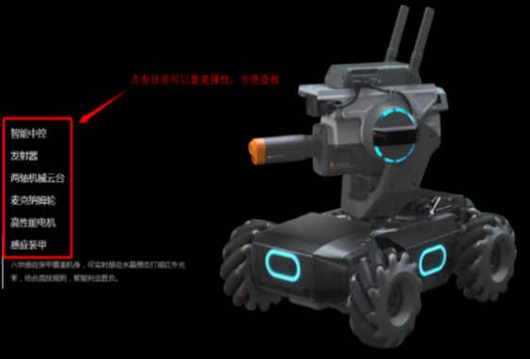

- Mecanum wheels are omnidirectional wheels that are often used on the chassis of robots in RoboMaster competitions. Please draw the common assembly sketch (top view) of the four Mecanum wheels on one robot, then indicate the rotational directions of each wheel when the chassis is moving to the right.
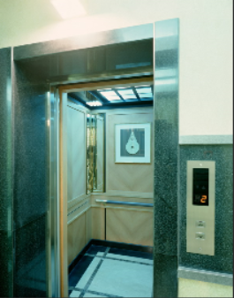
- Elevators are a common tool in everyday life. Please draw two sketches of a typical elevator door, one showing an open state and the other showing a closed state, and explain the transition process from one state to the other.
- Use SolidWorks to open the .step file.
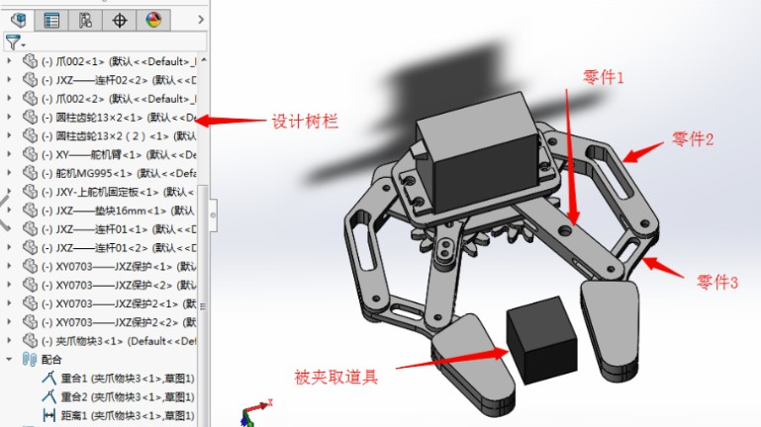
Part 3
Object
Part 2
Design Tree
Part 1
- According to the model, redraw parts 1, 2, and 3 in SolidWorks and provide screenshots of each part. Provide individual screenshots of the design tree to show your drawing process.
- Use the parts you just drew and other parts in the model to reassemble the claw again in SoildWorks. Set the final state of the claw as a closed state. Please provide six views of the final assembly.
- Application Questions
One of the effects of COVID-19 was that many couriers stopped picking up or delivering goods to peoples’ doors. Suppose you need to design an automatic delivery device to work with a quadcopter drone that could complete the following functions: customers will place four types of goods (10/8/6/4cm cube) that they need to deliver in an open space. The aircraft flies over at a fixed time, firmly grabs and holds the goods, and then transports it to a predetermined destination. Make sure the goods will not drop during flight.
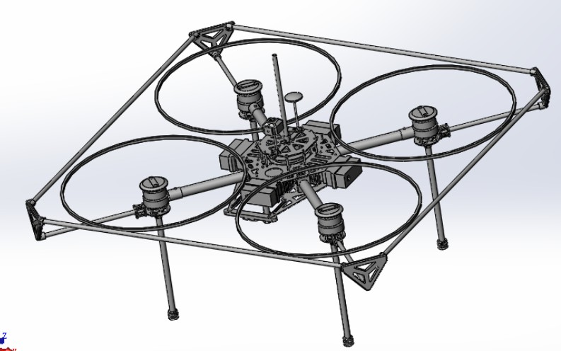
Note: Assume the weight of the goods is irrelevant, and damaging the goods with the claw is not an issue (Note: Using suction cups, tape, or Velcro as a clamping mechanism is forbidden). Assume the initial position of the goods is optimal and can be customized. No person can assist the aircraft during the collecting process. The aircraft model is as follows:
- In the following template, describe several structural schemes in text that can achieve the functions above. Then, analyze their advantages and disadvantages and explain your design ideas.
No | Solution Description | Pros and Cons/Risks | Design ideas  (explain how you came up with this solution)
1
2
- Choose one solution you think is the most suitable and draw out the 3D model (show screenshots of the model).
- Please select three parts from your designed mechanism and describe the manufacturing process and material selection (the machinery process and materials must be things you have used before and are familiar with).
- Advanced Level
This question is regarding the mechanical claw commonly used on educational robots. When point A is subjected to a horizontal force of 10N and the mechanical claw is in the middle state, the system is in a balanced state, ignoring the friction and dead weight of all parts, and replacing the rigid body of all parts. Please adjust the force diagram of part 3 and calculate the magnitude of each force.
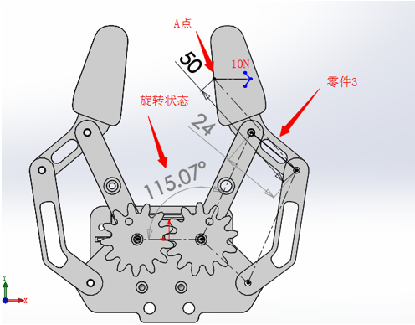
- Embedded System Direction Compulsory Questions
- Basic Level questions
- What types of communication (serial or parallel and well as simplex, half duplex, or full duplex) and maximum reach range do the following communication interfaces have?
Name | Serial/Parallel | Simplex/Half Duplex/Full Duplex | Max Reach Range
UART
SPI Bus
CAN Bus
SATA Cable
8080 Bus
- The following three images show the waveform of the target value and output value of three PID control systems with different parameters. Please analyze the problems of these three PID control systems. How should the parameters be adjusted to approach the given value? (Note: the yellow line is the target value and the blue line is the feedback value.)
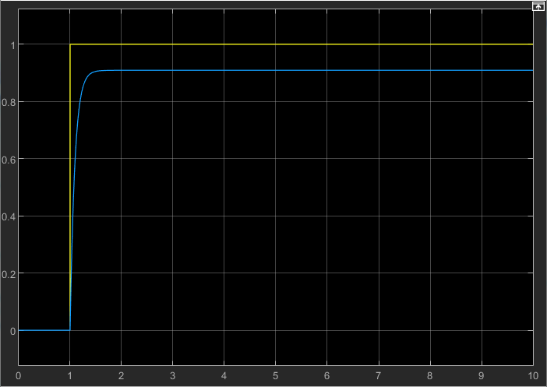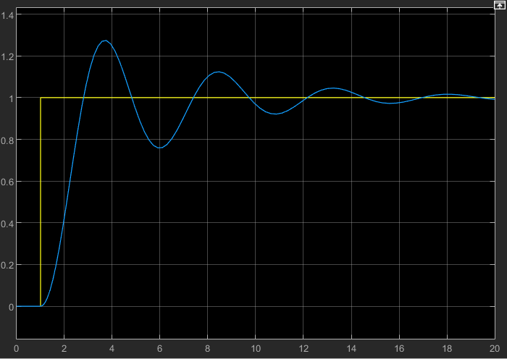
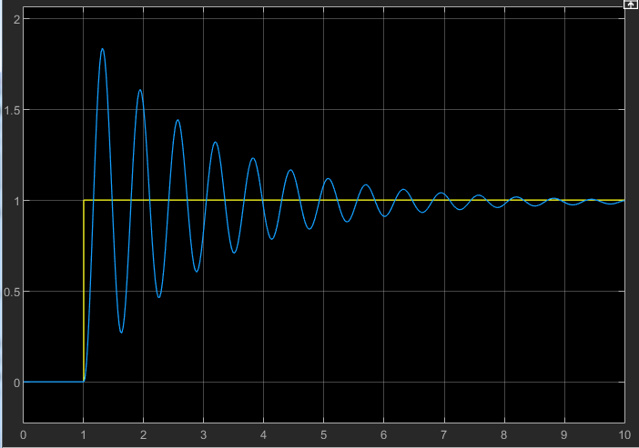
- Introduce the principles and applications (for optimal use occasion/environment) of the following distance sensors, and match them with the following four ranging objects: 1. Wall surface; 2. Ice surface; 3. Mirror surface; 4. Table legs.
- Ultrasonic Sensor
- Laser Distance Sensor
- Coding Practice:
- Write a function to judge whether a number (with no sign; Num) is the exponential power of a certain base (Root). If the Num is the exponential power of the Root, return 1, if not, return 0. Make sure your function is as efficient as possible. For example, when input Num is 4 and Root is 2, your code should return 1; when input Num is 5 and Root is 3, your code should return 0. You can only use C Language and Python.
C Language function declaration: int is_power (int num, int root)
Python function declaration: def is_power (num, root)
- All the values in the computer are converted to binary form for storage and operation, for example, the binary form of an unsigned integer 1234 is 10011010010. Please write a function to calculate the. number of 1 in the binary form of an unsigned integer. For example, 1234 —> 10011010010 = 5. You can only use C Language and Python.
C Language function declaration: int count_bits (unsigned int num)
Python function declaration: def count_bits (num)
- Application Questions
In 2020, the outbreak of COVID-19 has led many regions to adopt necessary home isolation orders. Suppose you need to design a drone to assist the government’s epidemic prevention mission. The drone is required to include the following functions:
(Quality, size, and endurance of the drone are not under consideration for this example.)
- It can detect and identify crowds in a relatively intelligent way as well as establish temperature detection;
- When necessary, the route needs to be automatically generated to guide the drone to a set return point;
- It has audio transmission and video transmission functions.
There are often many tall buildings in urban areas. When flying near tall buildings, conventional GPS signal is very poor. Please answer the following questions according to these scenarios. (Reference materials: DJI Mavic industry version, DJI T16 agricultural drone, fixed-wing aircraft that can take-off and land vertically)
- Yaw, pitch, and roll angles are terms used to describe the posture of the drone. Please briefly introduce the principle and algorithm flow of a drone posture algorithm. (Recommended word count: 180 words)
- Please design a sensor system solution that can achieve the tasks mentioned above. Draw the sensor block diagram, including the communication bus of each sensor. (Recommended word count: 260 words.
- Assume the drone is flying at a height of 50 meters and releasing an air-drop rescue supply. The forward speed of the aircraft is 10 m/s; the mass of the rescue supply is 0.1 kg; the acceleration of gravity is 9.8 m/s²; the air resistance is opposite to the speed direction with the magnitude k*v (k = 0.1). Please use the software to simulate the drop trajectory of the rescue supply. (It is recommended to use Python to map out the trajectory diagram. Use print in C language to output the coordinates during the iteration process)
- Advanced Level
Coordinate transformation is the process of transforming the description of the position of a spatial entity from one coordinate system to another. This is achieved by establishing a one-to-one correspondence between the two coordinate systems. Using relevant knowledge of coordinate transformation in three-dimensional spaces, answer the following questions:
- What is the representation or description of the mathematical structure used during coordinate transformation in three-dimensional space?
- Implement the following programs in the ROS operating system:
Given coordinate systems A and B, the position transformation between coordinate system A and coordinate system B is given as (x, y, z) = > (3, −2,0) and the angle transformation is given as (roll, pitch, yaw) = > (90°, 30°, 45°); There is a pose point M in coordinate system A, the position
coordinates (x, y, z) = (1,1,1), and the angle coordinates (roll, pitch, yaw) = (0°, 0°, 0°)
- Post the static coordinate system transformation between coordinate system A and coordinate system B;
- Using geometry_msgs :: PoseStamped as the type, pose topic information of pose point M (under the A coordinate system);
- Using geometry_msgs :: PoseStamped as the type, pose topic information of pose point N (under the B coordinate system) is published, so that point N and point M coincide in space;
- In the ROS visual interface rviz, display the TF transformation between coordinate systems A and B and the pose information of points M and N. Attach a screenshot as the answer.
- Algorithm Direction Compulsory Questions
- Basic Level questions
- In an indoor environment, which sensors can be used to determine the position and posture of an object? Provide three types of sensors.
- Data structure problem: What data structure characteristics can be found in Deque (double-ended queue)?
- Free respond question: In a two-dimensional environment, the sound velocity is 340 m/s. You receive the signals from signal generator located at (x1, y1), (x2, y2), (x3, y3) at time t0. The time when signals are generated by each of the generators are t1, t2, t3 (obviously t0 is later than t1, t2, t3). Find the coordinates of your current position.
- Algorithm problem: In the plane coordinate system, there are two coordinate axes, x-axis
and y-axis. We use (x, y) to represent the coordinates of the point. There is a point located at (x1, y1) and can move to eight adjacent positions (see the figure below). Movement Range: this point can only move within the range of 0≤x≤300,0≤y≤300. Given the starting position as (x1, y1) and the target position as (x 2, y2), what is the minimum number of times required to move from the starting position to the target position?
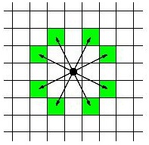

- Coding Practice:
Write a function that can find the maximum value of a certain equation via binary search or golden-section search in the most efficient way.
Examples of calling equation functions are as follows:
C Language
float equation_func (float num)
{
return –num * num + 2 * num;
}
Python
def equation_func (num) Return –num ** 2 +2 * num
C Language function declaration: float get_peak (float left_num, float right_num, float accuracy)
Python function declaration: def get_peak (left_num, right_num, accuracy)
- Application Questions:
In 2020, the outbreak of COVID-19 has led many regions to adopt necessary home isolation orders. Suppose you need to design a drone to assist the government’s epidemic prevention mission. The drone is required to include the following functions:
(Quality, size, and endurance of the drone are not under consideration for this example.)
- It can detect and identify crowds in a relatively intelligent way as well as establish temperature detection;
- When necessary, the route needs to be automatically generated to guide the drone to a set return point;
- It has audio transmission and video transmission functions.
There are often many tall buildings in urban areas. When flying near tall buildings, conventional GPS signal is very poor. Please answer the following questions according to these scenarios. (Reference materials: DJI Mavic industry version, DJI T16 agricultural drone, fixed-wing aircraft that can take-off and land vertically)
- Yaw, pitch, and roll angles are terms used to describe the posture of the drone. Please briefly introduce the principle and algorithm flow of a drone posture algorithm. (Recommended word count: 180 words)
- Please design a sensor system solution that can achieve the tasks mentioned above. Draw the sensor block diagram, including the communication bus of each sensor. (Recommended word count: 260 words.
- Assume the drone is flying at a height of 50 meters and releasing an air-drop rescue supply. The forward speed of the aircraft is 10 m/s; the mass of the rescue supply is 0.1 kg; the acceleration of gravity is 9.8 m/s²; the air resistance is opposite to the speed direction with the magnitude k*v (k = 0.1). Please use the software to simulate the drop trajectory of the rescue supply. (It is recommended to use Python to map out the trajectory diagram. Use print in C language to output the coordinates during the iteration process)
- Advanced Level
Coordinate transformation is the process of transforming the description of the position of a spatial entity from one coordinate system to another. This is achieved by establishing a one-to-one correspondence between the two coordinate systems. Using relevant knowledge of coordinate transformation in three-dimensional spaces, answer the following questions:
- What is the representation or description of the mathematical structure used during coordinate transformation in three-dimensional space?
- Implement the following programs in the ROS operating system:
Given coordinate systems A and B, the position transformation between coordinate system A and coordinate system B is given as (x, y, z) = > (3, −2,0) and the angle transformation is given as (roll, pitch, yaw) = > (90°, 30°, 45°); There is a pose point M in coordinate system A, the position
coordinates (x, y, z) = (1,1,1), and the angle coordinates (roll, pitch, yaw) = (0°, 0°, 0°)
- Post the static coordinate system transformation between coordinate system A and coordinate system B;
- Using geometry_msgs :: PoseStamped as the type, pose topic information of pose point M (under the A coordinate system);
- Using geometry_msgs :: PoseStamped as the type, pose topic information of pose point N (under the B coordinate system) is published, so that point N and point M coincide in space;
- In the ROS visual interface rviz, display the TF transformation between coordinate systems A and B and the pose information of points M and N. Attach a screenshot as the answer.

