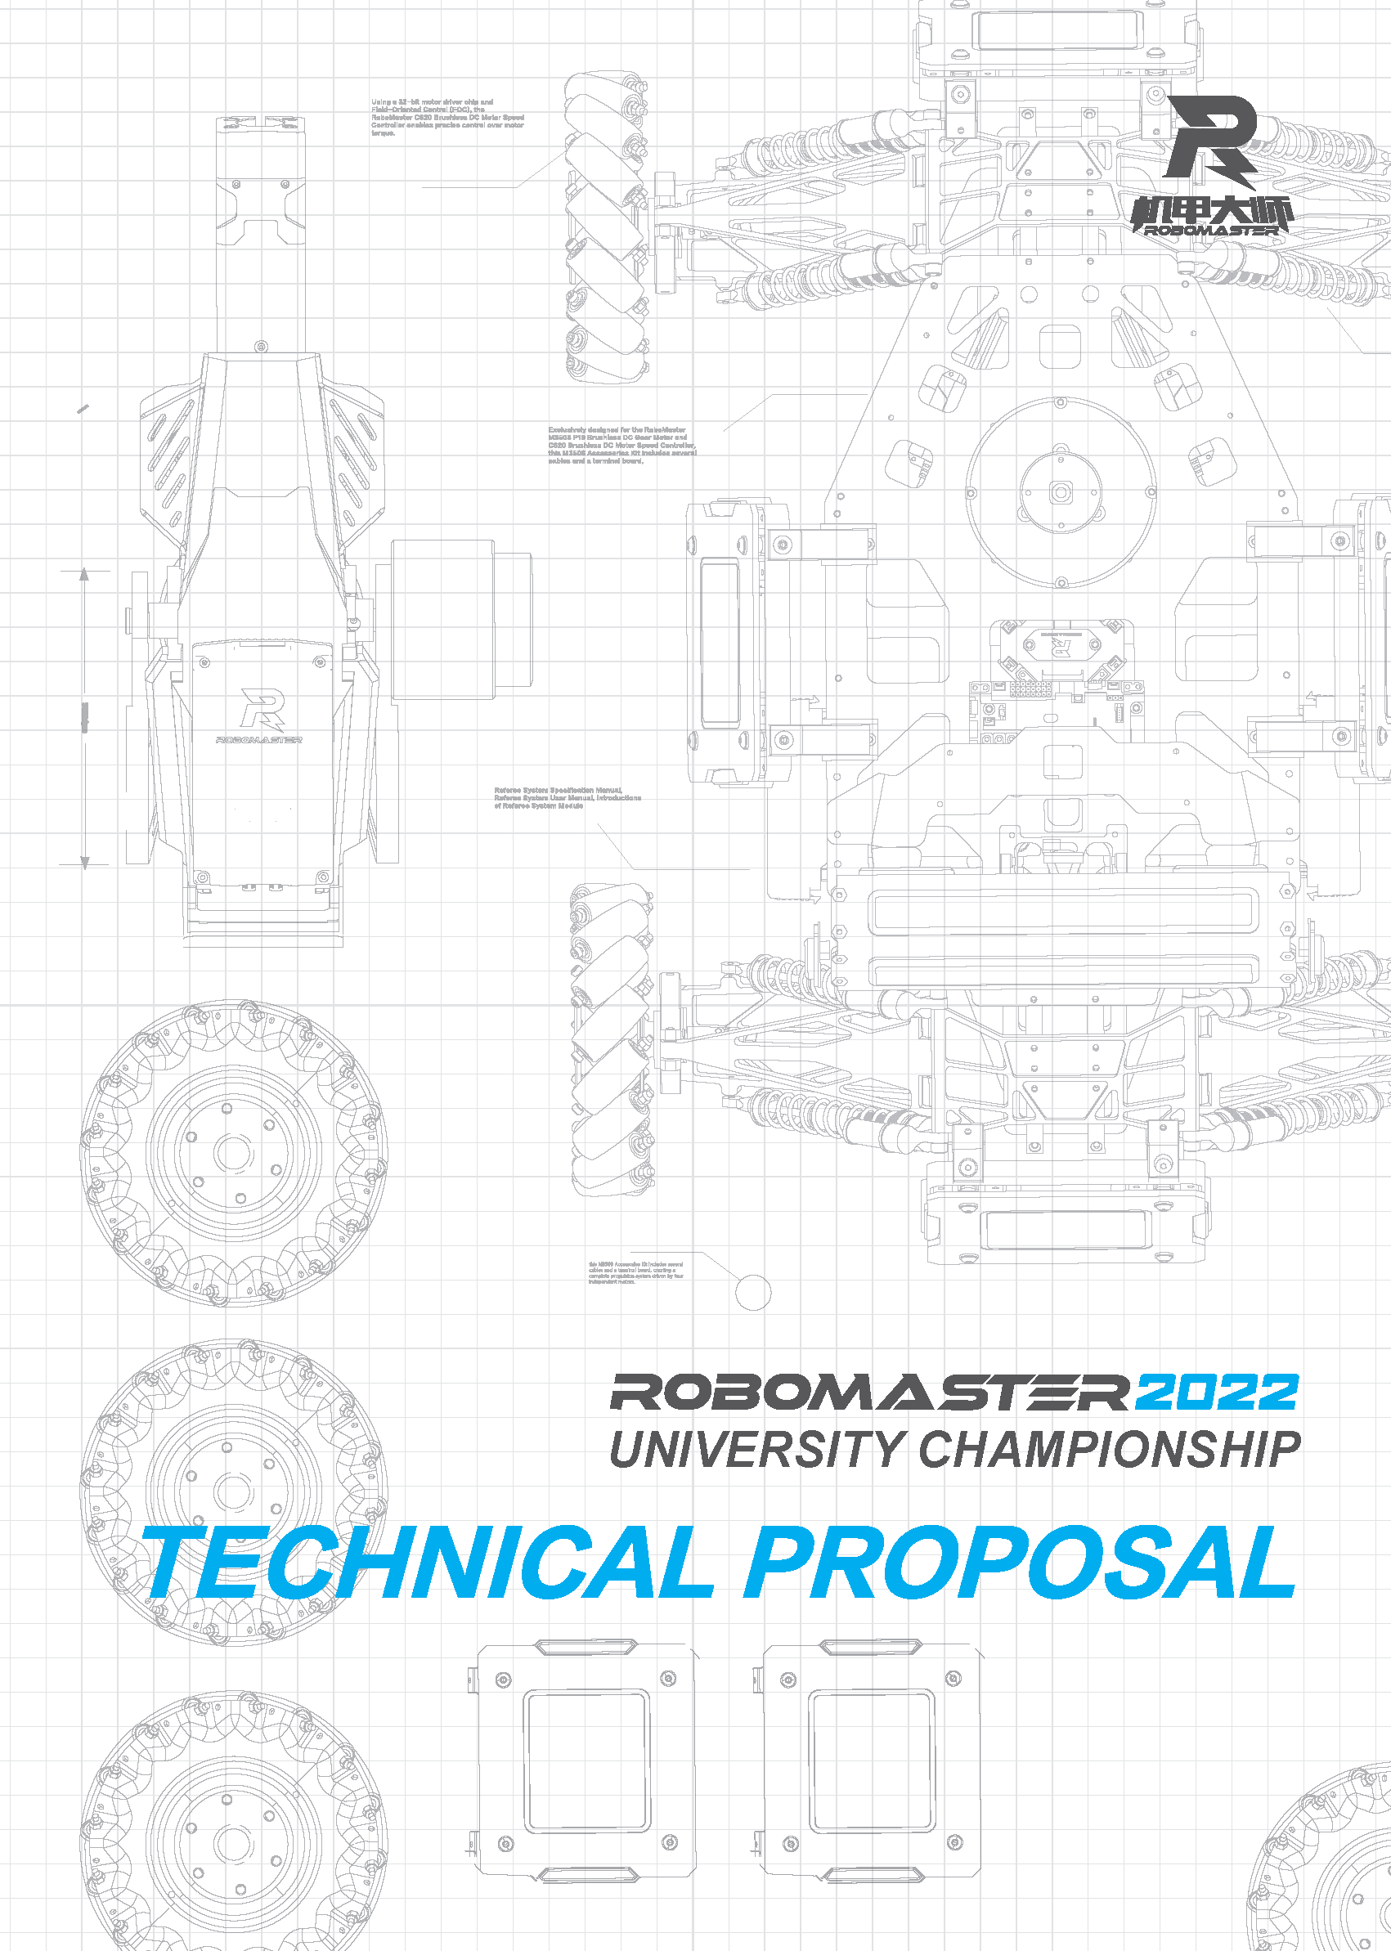

Table of Contents
1. Standard Robot 3
1.1 Analysis of Other Teams’ Standard Robots (5) 3
1.2 Overview of Robot Functions (10) 3
1.3 Core Robot Parameters (5) 3
1.4 Design Scheme (50) 3
1.4.1 Mechanical Structure 3
1.4.2 Hardware 4
1.4.3 Software 4
1.4.4 Algorithm 4
1.4.5 Other 5
1.5 R&D Iteration (20) 5
1.5.1 Version Iteration Record 5
1.5.2 Important Issues and Solutions 5
1.6 Member Contribution (5) 6
1.7 References (5) 6
2. Sentry Robot 7
3. Hero Robot 8
4. Engineer Robot 9
5. Aerial Robot 10
6. Dart System 11
7. Radar 12

Standard Robot

Analysis of Other Teams’ Standard Robots (5)

Overview of Robot Functions (10)
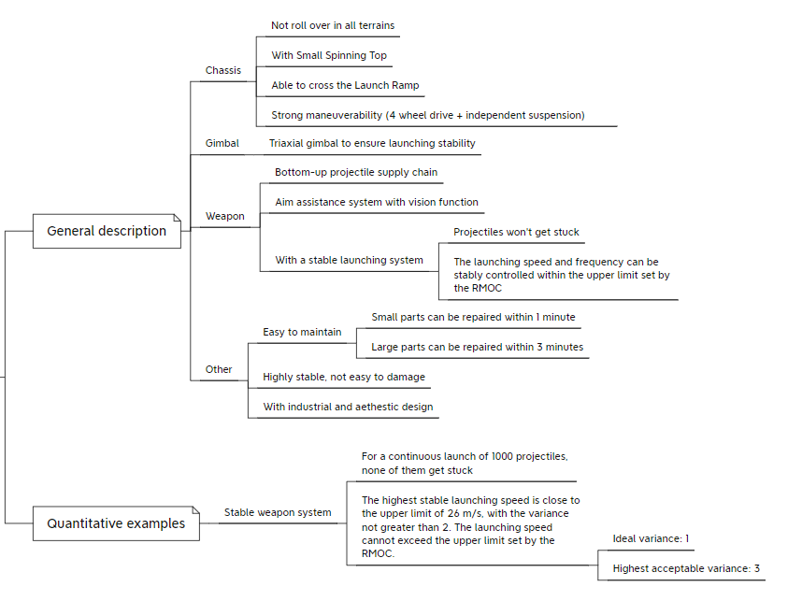

Core Robot Parameters (5)
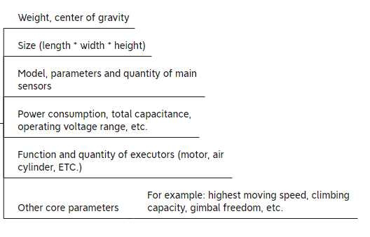

Design Scheme (50)

Mechanical Structure
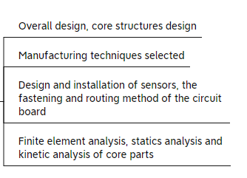

Hardware
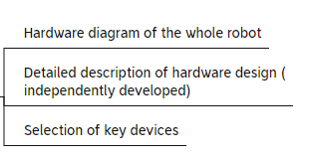

Software
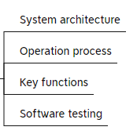

Algorithm
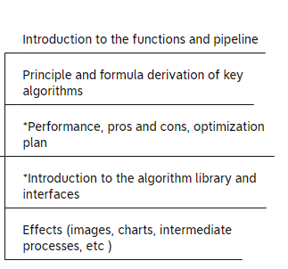

Other

R&D Iteration (20)

Version Iteration Record
Version or Phase | Detailed Description of Function or Performance | Completion Time
V1.0 |  | 2022.3.18
V1.1 |  | 2022.4.2

Important Issues and Solutions
NO. | Issue Description | Root Cause | Solution & Effect | Robot Version or Phase | Person in Charge
1 | 10 out of 100 rounds of projectiles launched by the Standard Robot at a speed of 25m/s will deviate from the ballistic trajectory by 15°±5°. |  |  | V1.0 | Mechanical Engineer: xxx  Hardware Engineer: xxx  Embedded Software Engineer: xxx

Member Contribution (5)
Name | Basic Information  (Major, Grade, Role) | Main Responsibilities | Contribution  (The total contribution of all members is 100%)
John | Computer science and technology, sophomore, software development lead | Responsible for the embedded system development of the entire robot, including chassis control, PTZ control, embedded environment development of the vision system, etc. | 30%

References (5)

Sentry Robot

Hero Robot

Engineer Robot

Aerial Robot

Dart System

Radar

