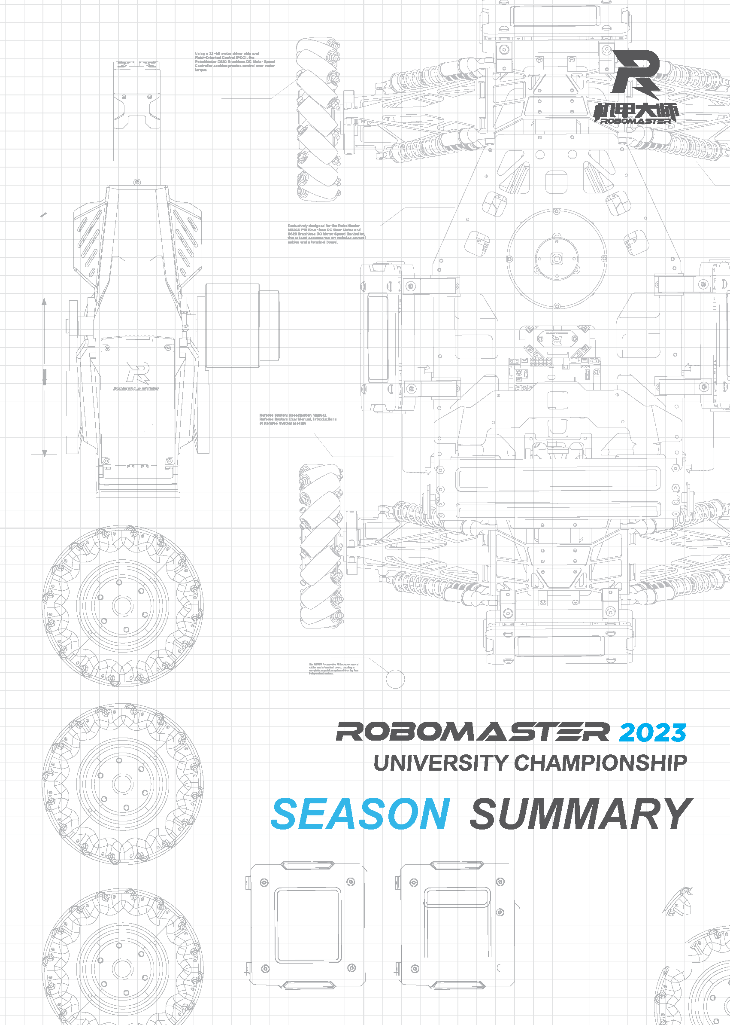

Prepared by XXX (team name), XXX (college/university name)
Released in (month) (year)
TABLE OF CONTENTS
1. Team Building Analysis (5) 3
1.1 Result Goals for This Season 3
1.1.1 Result-Goal Comparison for This Season 3
1.1.2 Cause Analysis for Discrepancies and Consistencies Between Results and Goals 3
1.1.3 Conclusion of Experience 3
1.2 Technical Breakthrough Goals for This Season 4
1.2.1 Comparison of Actual Technical Points Developed and Goals for This Season 4
1.2.2 Cause Analysis for Discrepancies Between Actual Technical Points Developed and Goals 4
1.2.3 Conclusion of Experience 4
1.3 Team-building Goals for This Season 4
1.3.1 Comparison of Actual Team Building Achieved and Goals for This Season 4
1.3.2 Cause Analysis for Discrepancies Between Actual Team Building Achieved and Goals for This Season 4
1.3.3 Conclusion of Experience 4
2. Cultural Building Analysis (10) 5
2.1 Cultural Building Review Analysis 5
2.2 Key Results Presentation 6
2.3 Management Culture Building Score 7
3. Project Analysis (30) 9
3.1 Rules Interpretation 9
3.2 Standard Robot 9
3.2.1 Comparison of Target Functional Requirements at Season’s Start and Actual Functions Achieved 10
3.2.2 Functions That Were Planned for but Not Achieved, and the Reasons 10
3.2.3 Functions That Were Competition Requirements but Not Achieved, and the Reasons 10
3.2.4 Functions That Were Planned for and Achieved, and the Reasons 10
3.2.5 Functions That Were Competition Requirements but Not Achieved, and the Reasons 10
3.2.6 Comparative Analysis of Reasons for Successful Achievement of Functions and Failure to Achieve Functions 10
3.2.7 Comparison and Analysis of Initial R&D Manpower Plan at Season’s Start and Actual Manpower Invested 10
3.2.8 Conclusion of Experience 10
3.3 Sentry Robot 10
3.4 Engineer Robot 10
3.5 Hero Robot 10
3.6 Aerial Robot 10
3.7 Dart System 10
3.8 Radar 10
4. Team Structure (10) 11
5. Infrastructure Review (10) 13
5.1 Available Resources 13
5.2 Collaborative Tool Usage 13
5.3 R&D Management Tool Usage 13
5.4 Resource Management 14
6. Financial Management (10) 15
6.1 Season Fund Analysis 15
6.2 Cost Control Plan 16
7. Team Rules and Regulations (10) 17
7.1 Mechanisms for Team Management 17
7.2 Review and Decision-Making Mechanism 17
7.3 xx Mechanism 17
8. Academic Innovation (15) 18

Team Building Analysis (5)
Review the goals in all areas of the season, including but not limited to:
① Result goals (the best results you wish to achieve or the minimum results you must achieve)
② Team-building goals (preferably quantifiable, such as: establishing a team system that can manage XX reserve members, and a teamwork system that can increase the work efficiency of X people to a certain level, etc.)
③ Technical breakthrough goals (technical points that don’t exist at the season’s start but can hopefully be developed)
The post-mortem of each goal should generally include four parts: goal review, result-goal comparison, cause analysis, and conclusion of experience.

Result Goals for This Season

Result-Goal Comparison for This Season

Cause Analysis for Discrepancies and Consistencies Between Results and Goals

Conclusion of Experience
This is a conclusion of the successes and failures in this season by reviewing the whole competition in depth, through a goal review, result-goal comparison, and cause analysis. It should include detailed elaboration, such as by citing examples, data, etc.
The conclusion of experience for each section must be derived from a goal review, result-goal comparison, and cause analysis. Discussions must not be vague and baseless.

Technical Breakthrough Goals for This Season

Comparison of Actual Technical Points Developed and Goals for This Season

Cause Analysis for Discrepancies Between Actual Technical Points Developed and Goals

Conclusion of Experience

Team-building Goals for This Season

Comparison of Actual Team Building Achieved and Goals for This Season

Cause Analysis for Discrepancies Between Actual Team Building Achieved and Goals for This Season

Conclusion of Experience

Cultural Building Analysis (10)

Cultural Building Review Analysis
(The following are the writing requirements. Please delete them after you have completed your write-up.)
The purpose of this culture building review is to look back on the culture-building actions undertaken throughout the season, to evaluate their effects and whether they were well-planned, as a reference for the planning of the next season.
Each team should divide their culture-building activities by quarter, and provide a comparison of their “original plans” and “actual implementation”, analyzing the reasons for any discrepancy between the two, and assessing the implementation and outcome of culture building in this season.
*You may refer to the table below for this write-up.
Quarter | Content
Q1 (September - November) | Original Plans:  September - Meal gathering, team building, and internal team culture training at start of school year  October - Team culture sharing  November - Team building
Actual implementation:
October - Meal gathering
November - Team building
Comparative analysis:
Consistencies:
Discrepancies:
Evaluation: Implementation, effectiveness…
Q2 (December - January)
Q3 (March - May)
Q4 (June – August)

Key Results Presentation
(The following are the writing requirements. Please delete them after you have completed your write-up.)
Based on the timeline above, please highlight the key activities and events in terms of team culture building, and fill out the table below.
When selecting key results, you may consider the following perspectives (including but not limited to):
- Tracking of activity effectiveness: Whether the expected goals were met, unexpected results were achieved, a breakthrough was achieved, etc., preferably supported by relevant data. The 3 points of analysis shown in the table below are only examples. Each team may describe their results based on their own situation.
- Do the key results include activities unique to the team? What are the highlights? Please analyze them based on the team’s actual situation.
*The key results can be demonstrated as per the table below. Each team may add or remove rows depending on their needs.
*Relevant evidence only has to be provided in the form of links.
Activity/Event | Links to Presentation Materials | Result Analysis
9.13 Team building at start of school year |  | Level of participation and response  Lasting effect  Delivery and implementation of cultural elements and values

Management Culture Building Score
Management | Score
Supervisor
Captain
Project Manager
PR Manager
Link to raw data file:
(The following are the writing requirements. Please delete them after you have completed your write-up.)
All team members (except management) are asked to score their captain, project manager, PR manager and supervisor based on the following standards. The (average) scores are to be filled into this form and compiled into an Excel file, the link of which shall be inserted after “Link to raw data file”.
*This section is only for the Organizing Committee to understand the culture building in each team. It is not factored into the overall scoring for culture building.
*Scoring Criteria:
Score | Assessment criteria
0-3 points | No culture-building activities, no interaction with the team members. He/she did not listen to and understand them.
4-6 points | Only a few culture-building activities were held, with infrequent interactions with the team members. He/she tended to ignore their real needs in the culture-building activities.
7-9 points | Interacted frequently with the team members, and able to listen to and understand them. Many culture-building activities were held that met the needs of the team members.
10 points | There was a clear culture-building plan, with many such activities held that met the needs of the team members. He/she interacted frequently with the team members, and was able to listen to and understand them, helping them explore themselves internally and externally, and fostering a pleasant team atmosphere.
*Reference template for the scoring document (the table is for reference only; please do not insert data directly into it)
Team Member (no real name required) | Supervisor | Captain | Project Manager | PR Manager
1 | 5 points | 6 points | 7 points | 8 points
2 | 6 points
3
4
Average Score | 5.5 points

Project Analysis (30)

Rules Interpretation
Interpret the competition rules for the season, analyze the discrepancies and consistencies between actual competition scenarios and rule interpretations, and conclude effective interpretations of the rules.

Standard Robot
Briefly describe the functional requirements at the beginning of the season, compare them with their actual implementation, and focus on analyzing functions that were planned for but not achieved and those that were competition requirements but not planned for, as well as the reasons for such failures. Conclude experiences from the requirements analysis and functional plans, to help teams improve in the next season. The data for the other robot types can be filled in accordingly as per the template.

Comparison of Target Functional Requirements at Season’s Start and Actual Functions Achieved

Functions That Were Planned for but Not Achieved, and the Reasons

Functions That Were Competition Requirements but Not Achieved, and the Reasons

Functions That Were Planned for and Achieved, and the Reasons

Functions That Were Competition Requirements but Not Achieved, and the Reasons

Comparative Analysis of Reasons for Successful Achievement of Functions and Failure to Achieve Functions

Comparison and Analysis of Initial R&D Manpower Plan at Season’s Start and Actual Manpower Invested

Conclusion of Experience

Sentry Robot

Engineer Robot

Hero Robot

Aerial Robot

Dart System

Radar

Team Structure (10)
The following table is for reference only. Focus on stating those members who stayed until the competition, compare the team’s composition at the start of the season, analyze the reasons for members’ departure, and conclude useful experiences from the building of the team as well as training and retention of new members.
Roles | Category | Role |  | Division of Responsibilities | Personnel Requirements
Supervisor
Advisor
Regular Members | Management | Captain
 |  | Vice Captain
 |  | Standby Captain
 |  | Project Manager
 | Technical Executive | Mechanical | Team Lead
 |  |  | Team Member
 |  | Electrical | Team Lead
 |  |  | Team Member
 |  | Algorithm | Team Lead
 |  |  | Team Member
 | Operation | Publicity
 |  | Sponsorship
 |  | Finances
Reserve Member |  | Mechanical
 |  | Electrical
 |  | Algorithm
 |  | Operation

Infrastructure Review (10)
Review the resources and software actually used against the planned available resources and software, analyze the reasons for any discrepancy, and conclude useful experiences.

Available Resources
Time | Source | Amount | Unit | Season Planning | Actual Usage | Causes for Discrepancies and Consistencies | Conclusion of Experience
Expenses Report | School/Department
Expenses Report | Sponsored
Materials | Sponsored
Materials | Legacy
Processing Resources

Collaborative Tool Usage
Perform a comprehensive analysis of the collaborative tools in the season plan and their actual usage. This includes, but is not limited to: the comparison of planned availability and actual usage and the reasons of any consistency/discrepancy, and problems solved by, scope and requirements of, and concluded experiences from their usage.
Note: Please ensure your analysis can be a useful reference to team members in the next season. A proper compilation and analysis can serve as a good foundation for teams in their long-term development.

R&D Management Tool Usage
Perform a comprehensive analysis of any discrepancy between the planned task allocation, progress management, tool usage, and the actual situation. as well as its reasons, and conclude experiences from any success or failure.

Resource Management
Type | Technical Aspect | Type | Link
xx Robot/  Common to all types of robots | Mechanical | Open-source materials | Link
Write here

Financial Management (10)
It includes but is not limited to the following analyses and conclusions.
1. Season fund analysis
2. Cost control plan
3. Fund-raising plan (if any)
4. Financial management plan (if any)
The above aspects include but are not limited to analyses and conclusions based on goal reviews, result-goal comparisons, reasons for discrepancies and consistencies, and conclusion of experience.

Season Fund Analysis
Analysis of season fund expenditure: Conclude experiences from the team’s budgeting, based on the planned budget and a comparison between that and the actual expenditure. Focus on how to formulate an improved and feasible plan in the new season, providing guidance on its planning.
Season Funds Table:
Item | Budget (yuan) | Actual Expenditure (yuan) | Notes
Standard Robots | xxx | xxx | xx
Engineer Robots | xxx | xxx | xx
Hero Robots | xxx | xxx | xx
Automatic Sentries | xxx | xxx | xx
Aerial Robots | xxx | xxx | xx
Darts | xxx | xxx | xx
Radars | xxx | xxx | xx
Travel | xxx | xxx | xx
Others (Operations, etc.) | xxx | xxx | xx
Total | xxx | xxx | xx
Notes: The above robots are those who were deployed on the battlefield. Backup robots shall be compiled in a separate table.

Cost Control Plan
Summarize the cost control plan for this season and list 3-5 specific cost control strategies/examples, including but not limited to finding alternative design plans with lower costs. In addition, you may also document and conclude experiences from any solved/unsolved financial problem.

Team Rules and Regulations (10)
Review the season plan, identify which rules were implemented in the season and which were mere formalities, and analyze the reasons for such, and conclude management experiences.

Mechanisms for Team Management

Review and Decision-Making Mechanism

xx Mechanism

Academic Innovation (15)
List competition-related patents (with their patent numbers), academic articles (with their titles), or open-source technical literature (with their forum addresses or open-source platforms links such as github), or any unpublished test reports, quantitative data, technical documents, etc., that may be meaningful for future seasons of the competition.

