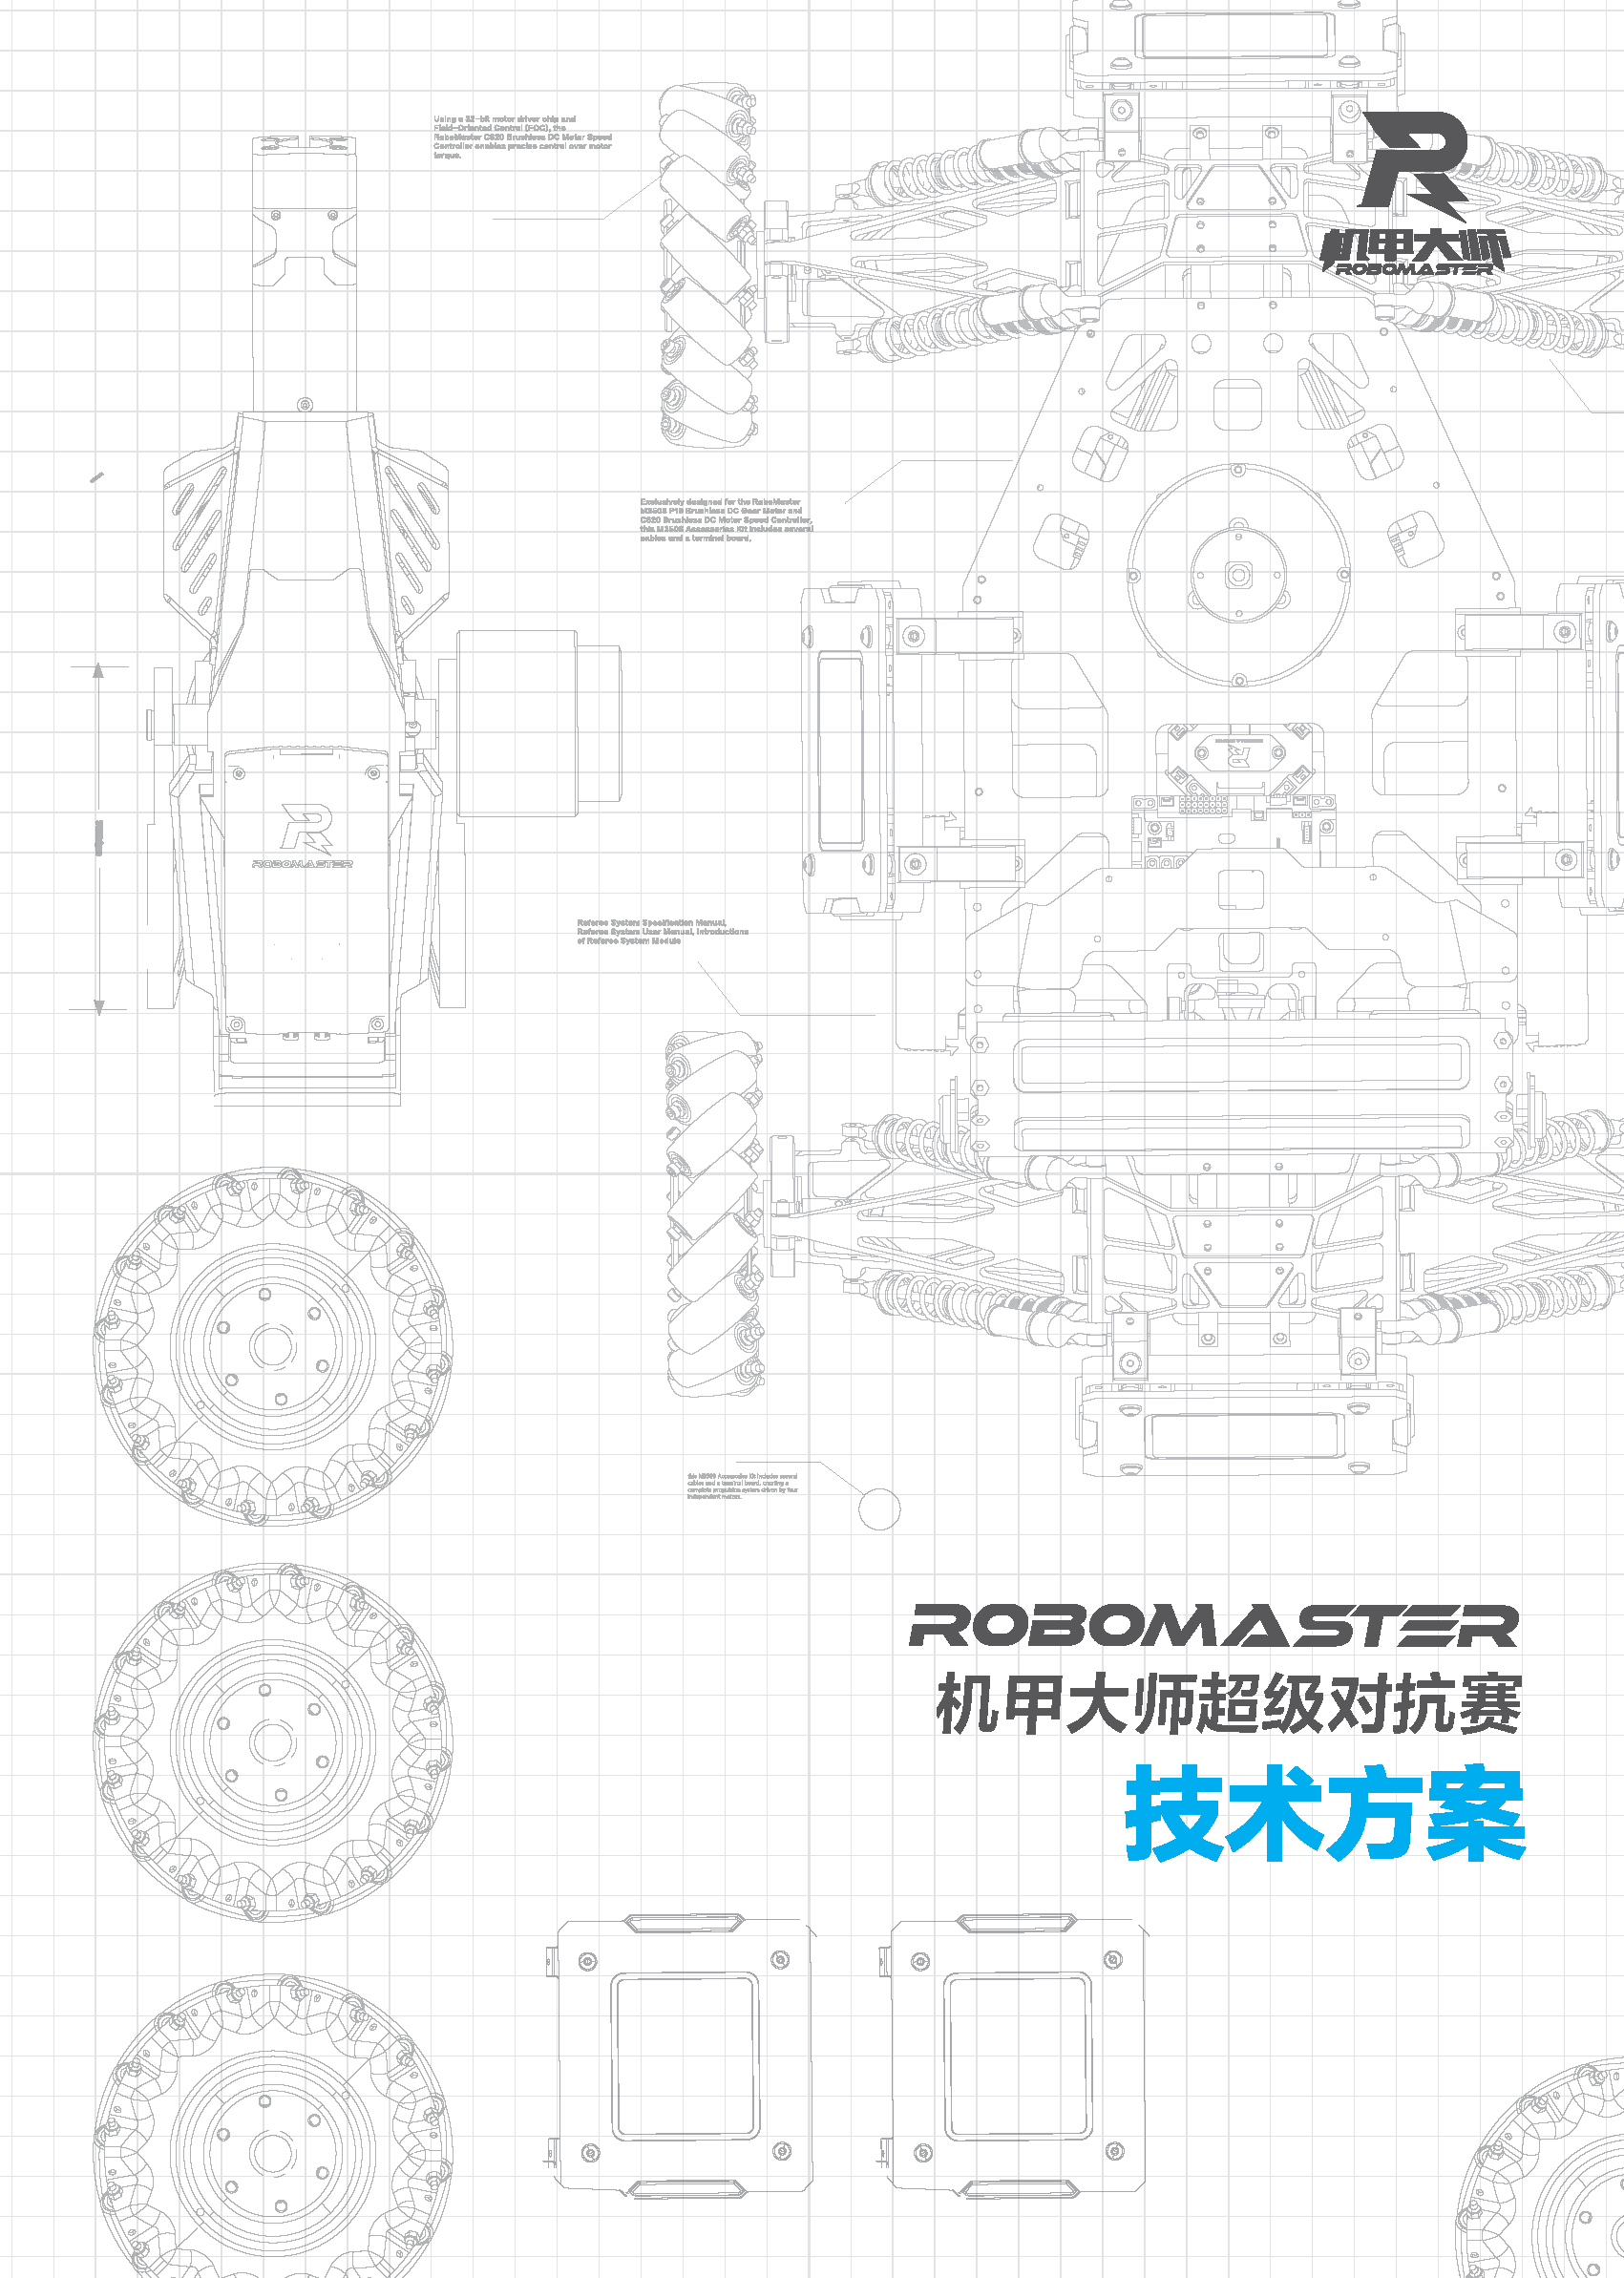

Prepared by XXX (team name), XXX (college/university name)
Released in (month) (year)

Foreword
This document has been prepared by XXX (team name), XXX (college/university name) for the RoboMaster 2023 University Championship. the key writers include:
Module | Author 1 | Author 2
Mechanical
Hardware
Software
Algorithm
Other

TABLE OF CONTENTS
前言 2
1. 概述 4
1.1 背景与目标 4
1.2 其它学校机器人分析综述 4
1.3 机器人功能定义 4
1.4 机器人核心参数 5
1.5 设计方案 5
1.5.1 机械结构设计 5
1.5.2 硬件设计 5
1.5.3 软件设计 6
1.5.4 算法设计 6
1.5.5 其它 7
1.6 研发迭代过程 7
1.6.1 测试记录 7
1.6.2 版本迭代过程记录 7
1.6.3 重点问题解决记录 7
1.7 团队成员贡献 8
1.8 参考文献 8
1.9 技术方案复盘 8
1.9.1 赛场性能表现情况分析 8
1.9.2 赛场性能表现与规划对比分析 8
1.9.3 经验总结 8

Introduction

Background and Objectives
Define the background and objectives of the technical plan based on two questions: Why do it, and to what extent (goals).

General Analysis of Robots From Other Universities
Review pasty competition videos, open-source materials from other universities, forums, and other information, to analyze the degree of completion and technical level of other universities’ robots in terms of various functions, and outline the areas worthy of reference or with room for improvement.

Robot Functional Definition
Define the functions of Standard Robots (preferably in quantitative terms) based on your actual situation.
The following is for illustrative purposes only. Please describe in a manner most appropriate for your own plan.
- Examples of Standard Robot Functions
  - Chassis Functional Design
    - Does not overturn in all terrain
    - Has a small spinning top function
    - Can pass over a launch ramp
    - Highly mobile
      - 4-motor independent suspension
  - Gimbal Design
    - 3-axis gimbal ensures shooting stability
  - Shooting System
    - Enables the lower projectile-reloading link
    - Auxiliary sighting device with vision
    - Stable system
      - No projectile jams
      - Launch speed and frequency can be controlled stably within the official maximum limit.
  - Miscellaneous Functions
    - Easy to maintain
      - Small damaged modules can be repaired within 1 minute
      - Large damaged modules can be repaired within 3 minutes
    - Highly stable and robust
    - Aesthetically pleasing
- Examples of Functional Quantification
  - Stable shooting system
      - The jam rate for 1000 consecutive projectile shots is 0.
      - Stable at maximum launch speed of 26 m/s
      - Launch speed variance is less than 2.

Robot Core Parameters
Describe the core parameters of the complete robots, including but not limited to the following.
Name | Parameter
Weight, center of gravity
Dimensions (length, width and height)
Primary sensor model, parameters, and quantity
Circuit power consumption, total capacity of all capacitors, operating voltage range, etc.
Descriptions of the purposes and quantities of executive devices (motors, cylinders, etc.)
Other core performance parameters of robots, such as: Maximum moving speed, ascending angle, gimbal’s degrees of freedom, etc.

Design Scheme
The importance of different robot types, machines, hardware and algorithms varies. Members of the judging committee will assign weightage to their scores based on importance. Please provide a write-up based on your team’s actual situation.

Mechanical Structure Design
- Description of the overall mechanical structure design/core structure design
- Process selection
- Design and installation of sensors, securing and routing of circuit boards
- Finite element analysis and static analysis of core parts

Hardware Design
- Block diagram of machine hardware
Descriptions of the connection block diagram (visio) for each hardware module, labeling communication standards, and fusion power tree.
- Detailed hardware design (self-developed)
Self-developed circuit board function descriptions, design schematics, peripheral interfaces, etc., with test reports and record descriptions for self-developed single boards.
- Key device selection
A. Selection descriptions for key devices such as the main control platform, drivers, power tubes, and sensors.
B. For key devices, you may compare the advantages and disadvantages of various solutions , such as in terms of cost, size, performance indicators, etc., based on the actual situation.

Software Design
- System Architecture
The system hierarchy and the functions of each level. List the third-party middleware and modules used, such as RTOS, file system, log system, GUI, protocol framework, etc. Host development and debugging environment.
- Operating Process
The overall operating process, data flow and processing of the software.
- Key Functions
Descriptions of core functions, the problems solved, and the technologies used.
- Software Test
Introduction to the test protocol, and the test execution and its results.
The above goal framework is for reference only. You may change the structure and manner of description. It is sufficient as long as the software’s implementation is clearly described, and focus should be given to describing self-designs, software system architecture, and key completed functions.

Algorithm Design
- Introduction to the functions, and pipeline
- Important algorithmic principles and formula derivations
- Algorithmic performance, pros and cons analysis, and optimization plan
- Introduction to the algorithm library, and interface descriptions
- Algorithm results (show images, charts, process flows, etc.)

Miscellaneous
Descriptions of R&D investments other than for machinery, hardware, software and algorithms, such as: industrial designs, U I interactive development.

R&D Updating Process
Functions, problems found, problem locating analysis, and descriptions of improved solutions completed at different stages or versions during the R&D process.
The following templates are for reference only and can be altered as needed.

Test Records
Test the various functions of robots, and record the test environment, test equipment, and other information.

Version Update Records
Version number or phase | Detailed description of function or performance | Completion Date
V1.0 |  | March 18, 2022
V1.1 |  | April 2, 2022

Key Problem Solving Records
No. | Issue description | Cause of problem | Solution plan & its actual effect | Robot version number or phase | Solving personnel
1 | When a Standard Robot fired 100 projectiles at 25 m/s, about 10 of them deviated from the trajectory by 15° ± 5°. |  |  | V1.0 | Mechanical engineer: xxx  Hardware engineer: xxx  Embedded software engineer: xxx

Team Members’ Contribution
The criteria for assessing contribution are set by the team and should correlate positively to the robots’ overall end results and quality.
Name | Basic information  (specialization, year of study, role in the team) | Descriptions of main responsibilities | Contribution score  (the total contribution from all members is 100%)
A | Computer Science and Technology, Second Year, software developer | Responsible for the embedded development of entire robots, including chassis control, gimbal control, embedded environment development for vision systems, etc. | 30%

References

Post-mortem of Technical Plan
Review the technical plan for this season, and analyze and evaluate whether it achieved the expected results based on actual performance on the battlefield.

Battlefield Performance Analysis
Objectively review the team’s actual performance on the battlefield. You may analyze the implementation of technical plan based on the definitions of robot functions and the core parameters of robots.

Comparative Analysis of Planned and Battlefield Performance
Analyze discrepancies with the technical plan and their reasons, based on the plan’s implementation.

Conclusion of Experience
Reflect on and conclude practical experiences from robot design based on the team’s actual resource investment and current technical status.

