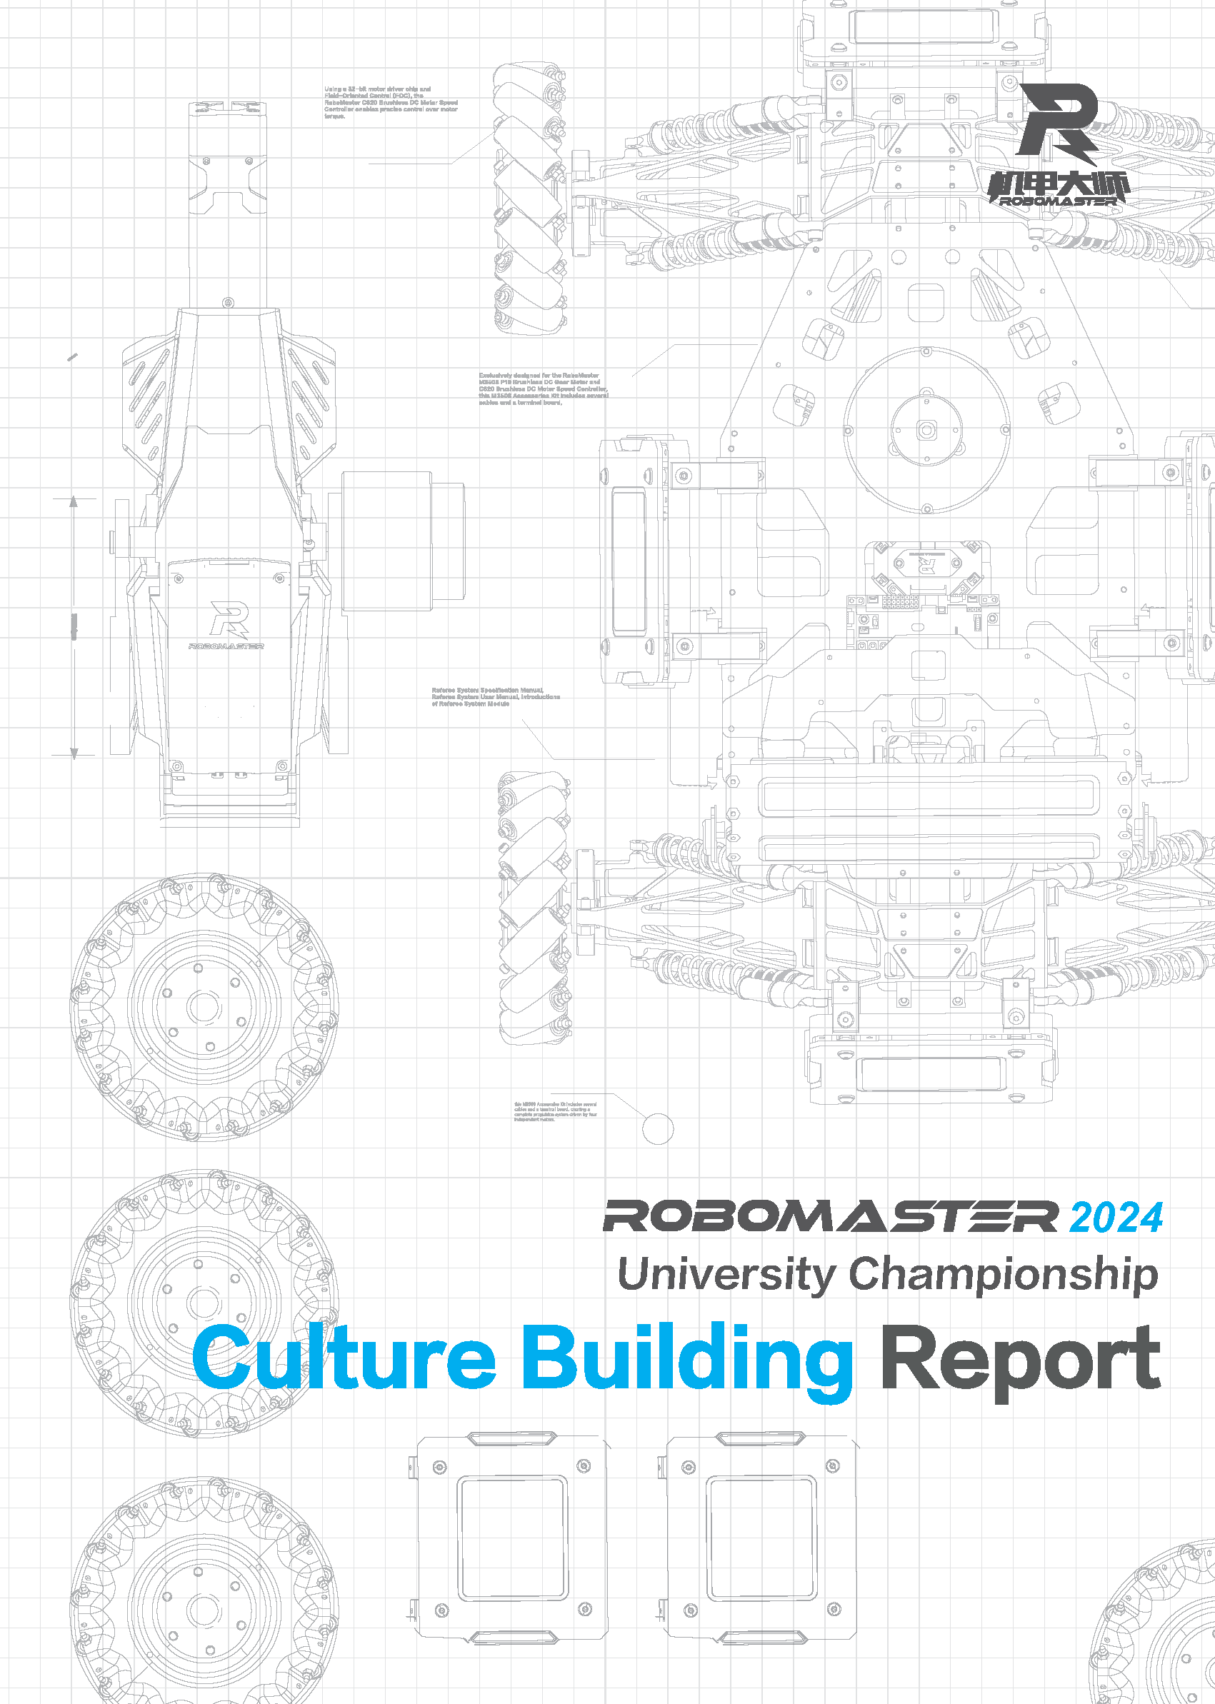
Prepared by XXX (team name), XXX (college/university name)
Released in (month) (year)

Foreword
This report has been prepared by XXX (team name), XXX (college/university name) for the RoboMaster 2024 University Championship. The key writers include XXX and XXX.

Perception and Interpretation of the Competition's Content and Culture
(The following are the writing requirements. Please delete them after you have completed your write-up.)
Note: Avoid copying or quoting content such as competition introduction and rules at length from official documents. It is required to incorporate your own analysis.
The team management is required to conduct a survey among all team members and evaluate their perception and understanding of the competition culture based on their real experiences and opinions. Please think and discuss in, but not limited to, the following aspects, and summarize the findings in a concise manner:
- What's your understanding and interpretation of the RM culture? What cultural concepts attract you the most?
- What's your understanding of the purposes behind establishing competition rules and designing competition details?
- Does this competition embody the RM culture?
Please analyze in the above aspects based on the data collected from the survey among team members. Include additional opinions and suggestions as required.

An Overview of the Core Team Culture
(The following are the writing requirements. Please delete them after you have completed your write-up.)
Every RM team should cultivate its own unique culture. Culture has its roots in history and develops through experiences. The core culture of a team should be built upon the evolving goals and direction shaped by the team's past experiences. It serves as a guiding spirit that unifies and directs every team member toward a common destination.
Please think and discuss in, but not limited to, the following aspects:
- How do you convey and promote your origin and initial purpose of establishment? (Highlight key actions)
- What's your uniqueness among the others? What kind of team are you? (Explain the adjectives you use to showcase your uniqueness in detail. Please use no more than three adjectives to demonstrate your distinctive qualities.)
- Values reflect the spirit of a team and its pursuit and understanding of the competition. Briefly describe the values that you all recognize and adhere to. (List your values and slogans and explain their origin and significance, such as "Compete for growth," "Original aspiration over results," "Growth over results," "Challenge our limits," "Broaden our horizons," and "Find friends with shared goals and vision.")

Concrete Proposals for Team Culture Building
(The following are the writing requirements. Please delete them after you have completed your write-up.)
Team culture building should be implemented throughout the entire season with the aim to foster greater cohesion within the team and improve problem-solving efficiency. When planning team culture building, the Captain, PR Manager, or other team management personnel can think and discuss in, but not limited to, the following aspects:
- Purpose of team culture building: disseminate team and competition culture
- Goals of team culture building: frequency of cultural exchange activities, frequency of internal cultural activities, awareness of surrounding cultures, and the like.
- Plan execution

