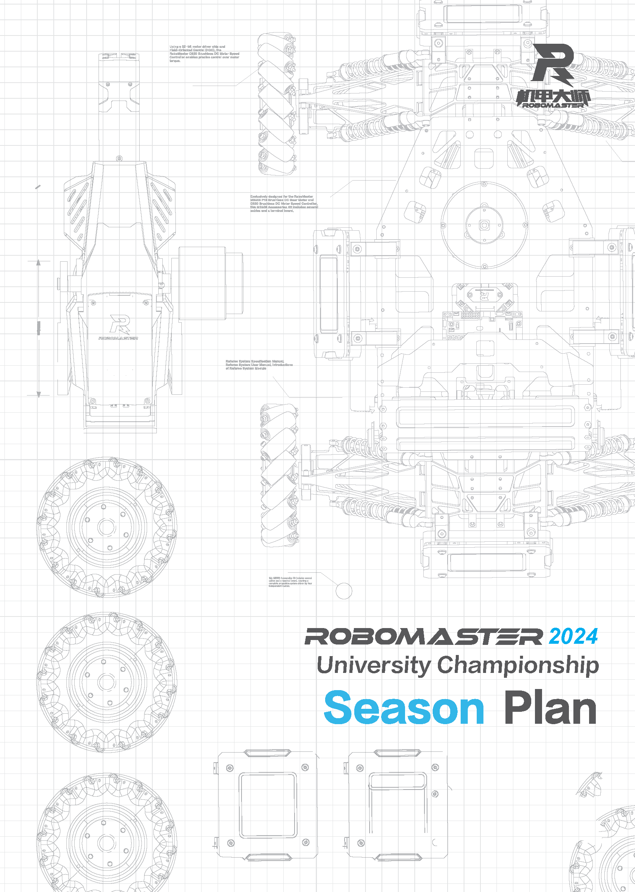
Prepared by XXX (team name), XXX (college/university name)
Released in (month) (year)
TABLE OF CONTENTS
Foreword 4
1. Team Goals (5) 5
2. Project Analysis (50) 6
2.1 Analysis of Previous Season's Project 6
2.2 Interpretation of This Season's Rules 6
2.3 R&D Project Plan 6
2.3.1 Standard Robots 6
2.3.2 Hero Robots 7
2.3.3 Engineer Robots 7
2.3.4 Sentry Robot 7
2.3.5 Aerial Robots 7
2.3.6 Dart System 7
2.3.7 Radars 7
2.3.8 Human-Machine Interaction 7
2.4 Technical Reserve Plan 7
2.4.1 General Technical Reserve 7
2.4.2 Robot-specific Technical Reserve 7
3. Team Structure (10) 8
4. Resource Availability Analysis (10) 11
5. Publicity and Business Plans (10) 13
5.1 Publicity Plan 13
5.2 Business Plan 14

Foreword
This report has been prepared by XXX (team name) for the RoboMaster 2024 University Championship. The key writers include:
Module | Writer 1 | Writer 2 | Writer 3 | Writer 4 | Writer 5
Mechanical
Hardware
Software
Algorithm
Management
Publicity
Business

Team Goals (5)
(The following are the writing requirements. Please delete them after you have completed your write-up.)
- Goals
Team goals should be challenging yet attainable, while aligning with the team's actual situation. Considerations for setting team goals encompass a range of factors, including but not limited to:
- Available resources, such as funds, manpower, technical expertise, open source materials
- Projected fundamental and advanced goals within a season based on past experience
- Current technological and skill levels of other teams
Set the team goals for each area in this season after team discussions, including but not limited to:
- The best results you wish to achieve or the minimum results you must achieve in the Regional Competition/Final Tournament.
- Team-building goals (preferably quantifiable, such as establishing a team system that can manage X reserve members, and a training system that can train Z new members under the guidance of Y senior members).
- Technical breakthrough goals: milestone technologies that the team currently cannot but aspires to develop in this season. Please describe only one or two of the most challenging and valuable technical points and provide the detailed plan in the Project Analysis section.
- Basis for Goal Setting
Please summarize your process of thought and explain the rationale behind setting the aforementioned goals.
- Actions for Progress Tracking
After the goals are set, it is essential to monitor the progress, identify the gaps, and make necessary reflections and adjustments to ensure the goals are achieved. Please briefly describe your actions for progress tracking, such as how you will implement the progress plan.

Project Analysis (50)

Analysis of Previous Season's Project
(The following are the writing requirements. Please delete them after you have completed your write-up.)
Review the summary of the previous season and analyze the project's success factors and challenges. This helps you gain insights into the planning and implementation process of a project and enable you to formulate the project analysis and R&D plans for the new season.
- Summary of experience from the previous season (with a focus on aspects applicable to this season)

Interpretation of This Season's Rules
(The following are the writing requirements. Please delete them after you have completed your write-up.)
Please provide your team's interpretation of the rules for this season. Avoid copying or quoting from official documents such as competition rules at length. It is required to incorporate your own analysis.
- Analysis and interpretation of the overall rules
- Analysis of the modifications in the rules
- Comprehensive understanding of the technical areas manifested by the rules

R&D Project Plan

Standard Robots
(The following are the writing requirements. Please delete them after you have completed your write-up.)
Include requirement analysis, the design concept, the R&D schedule, the manpower plan, and analysis of technical challenges.
- Analyze the functional requirements for the robot in combination with the rules
- Describe the preliminary design concept

Hero Robot

Engineer Robot

Sentry Robot

Aerial Robot

Dart System

Radar

Human-Machine Interaction
(The following are the writing requirements. Please delete them after you have completed your write-up.)
Human-machine interaction refers to:
- Enriching the custom UI function of the operator client through inter-robot communication
- Controlling robots through unconventional keyboard and mouse operations using custom controllers
If you have planned the use of relevant functions for this season, describe the details here.

Technical Reserve Plan
(The following are the writing requirements. Please delete them after you have completed your write-up.)
A technical reserve plan involves the technologies for future seasons, such as automatic positioning and navigation algorithms, instead of the technologies employed in the current season, such as gimbal control and automatic aiming.
Technical reserve involves accumulating general and long-term technologies that are not specific to a particular robot type or confined to a single season. The technologies are classified into two types: technologies that the team currently lacks but aims to acquire in the future, and technologies that the team already possesses but seeks to optimize from a medium to long-term perspective.

General Technical Reserve
Applicable to all types of robots.

Robot-specific Technical Reserve
Applicable to a specific type of robot.

Team Structure (10)
(The following are the writing requirements. Please delete them after you have completed your write-up.)
Please use a table or tree diagram to clarify the hierarchical relationships and connections between all positions and groups.
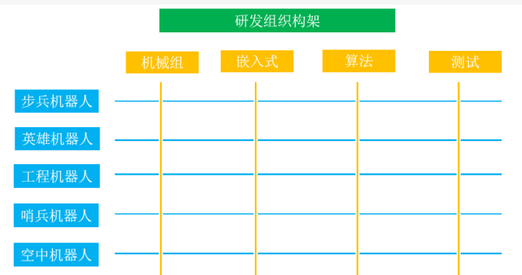
Aerial Robots
Sentry Robots
Engineer Robots
Hero Robots
Standard Robots
Testing
Algorithm
Embedded System
Mechanical
R&D Organizational Structure
Reference for R&D Organizational Structure
- Organize the overall structure of your team based on the actual situation. The table is for reference purposes and can be modified as required. If you prefer a different format to demonstrate the structure, you can remove the table and add other content.
- When setting position responsibilities, remember to take into account team culture building and legacy development and to clarify the division of responsibilities for the two aspects within the team.
Roles | Category | Positions |  | Responsibilities | Recruitment Requirements | Number
Supervisor
Advisor
Regular Members | Management | Captain
 |  | Vice Captain
 |  | Project Manager
 | Technical Executive | Mechanical | Group Leader
 |  | Mechanical | Group Member
 |  | Electrical | Group Leader
 |  | Electrical | Group Member
 |  | Computer Vision Algorithm | Group Leader
 |  | Computer Vision Algorithm | Group Member
 |  | Tactical Coach
 | Operations | Publicity
 |  | Sponsorship
 |  | Finances
Reserve  Members |  | Mechanical
 |  | Electrical
 |  | Computer Vision Algorithm
 |  | Operations
- Responsibilities: Specify the responsibilities of different positions during team operations, such as how involved Captain and Vice Captain should be in team affairs, the process for making significant team decisions, and the differences in daily tasks between Regular Members and Reserve Members. Please emphasize the actual tasks assigned to each position within the team while avoiding directly copying the responsibilities outlined in the Participant Manual.
- Recruitment Requirements: Describe the capabilities required for different positions, namely the corresponding requirements for team members to fulfill their responsibilities. These requirements encompass specific technical or management capabilities.
- Number: Estimate the number of persons required for each position based on the team's plan. Ensure a rational and ample allocation of tasks among team members while accomplishing the planned goals.
- Tactical Coach: This position can be permanent, temporary, or not established, depending on the team's actual situation. It can be held by an R&D member or an Advisor, or it can be separately recruited. In all cases, it is essential to specify the team's plan for this position in this season under the Responsibilities column.
Key Takeaways:
- Typically, Technical Executive is divided into three groups, each with a Group Leader. Group Leaders are expected to possess strong coordination, professional, and technical capabilities. They should exhibit superior technical expertise within the groups and foster an environment that allows group members to have ample opportunities for personal development.
- In general, a team requires Test Personnel (not included in the table but can be added as required), but they are not categorized into separate groups. Their responsibilities are assumed by Technical Executive members, including module testing, whole robot function testing, and battle testing between robots during the Preparation Period. Test Personnel shall have the right to determine whether a development task has been completed. Group members will eventually compete to be selected as the Operator in the competition.
- In general, a team can be divided into different project groups by robot type (not included in the table but can be added as required). Each project group can be assigned a Product Manager (robot-specific leader), who should preferably be an experienced team member that is knowledgeable and familiar with various technical areas, perceptive about robotic requirements, and is able to determine the level of task priority. Captain discusses with the Product Managers on the positioning and functions of each robot type for the purpose of respective project requirements. Each Product Manager will then discuss with their own project group members and confirm project requirements. Additionally, Product Managers also need to determine the required manpower with Group Leaders. Ultimately, the team will formulate a project plan based on the requirements and start implementing it, the progress of which shall be monitored by Project Managers.

Resource Availability Analysis (10)
(The following are the writing requirements. Please delete them after you have completed your write-up.)
- Resource usage review
Review the resource usage of the previous season with a particular focus on examining the irregularities in resource usage and cost control. Outline the targeted optimization measures in these respects for this season and evaluate their feasibility (a summary of these optimization measures is required at the end of the season).
- Overview of available resources for this season
Category | Source | Resource Description | Initial Use Plan
Funds
Materials
Processing Resources
Publicity Resources
XX Resources
- Overview of the budget plan (please present a detailed version in the Budget Report Excel file)
Module | Available Funds | Remarks (If Any)
Standard
Hero
Engineer
Sentry
Drones
Darts
Radars
Operations
Travel
Others
Total
- Resource availability analysis
Analyze how available resources such as funds, technologies, personnel, and time can ensure the successful implementation of the R&D project plan. Evaluate whether existing available resources are adequate to fulfill the plan, identify potential risks of resource insufficiency, and devise tailored strategies to mitigate these risks.

Publicity and Business Plans (10)

Publicity Plan
(The following are the writing requirements. Please delete them after you have completed your write-up. Insert content such as images and links as required.)
The publicity plan specifies the team's year-long publicity activities. The Season Plan requires the team to incorporate, but not limited to, the following:
- Goals: Based on the team's actual situation, tailor the overall style of the publicity content to resonate with team members, foster a stronger sense of teamwork and unity within the team, disseminate the team's culture and spirit, and gain support from school leaders and teachers.
- Indicators: Summarize and categorize all existing publicity channels for the team, and set appropriate indicators based on the actual situation.
*Please present this information in a table. List the data by the end of the previous season and set indicators for this season after comparison.
 |  | Season 2023 |  |  | Season 2024
Platform | Account | Total Exposure | Number of Deliverables | Average Exposure | Total Exposure | Number of Deliverables | Average Exposure
- Publicity Plan: The team member responsible for publicity is required to closely monitor and manage significant milestones in the publicity timeline and ensure proactive planning and preparation for both online and offline activities, which include external publicity activities and internal team building activities. When dealing with large-scale events involving multiple groups, it is essential for the person in charge to define the roles of the publicity group in these events. Please provide clear and concise information.
*Please present the information in a table and follow a chronological order. Briefly introduce the activities and corresponding goals, and add remarks if any.
*The content in the table is for reference purposes. Please delete it before you fill in the table.
Time | Events | Goals | Activities | Remarks
Sept-Oct 2023 | Recruitment | Recruit as many reserve members as possible to provide a sufficient pool of candidates for subsequent evaluation and selection | - Student organizations recruitment  - Publicity activities targeting freshmen and sophomores at study halls  - Information sessions
- Merchandise Plan: Fill in the information in line with the team's actual publicity status, including the planning of designing new merchandise and revitalizing traditional merchandise.

Business Plan
(The following are the writing requirements. Please delete them after you have completed your write-up.)
Please include the following key points in the team's business plan:
- Sponsors Plan
The sponsors plan can encompass the following elements: categorizing sponsors by industry, defining target numbers and scales, specifying cooperation models (including sponsor classification), and identifying channels (such as alumni associations) for sourcing sponsors.
- Resource Advantages and Highlights for Sponsorship
Identifying and listing the resources that the team can offer to potential sponsors will help facilitate collaborations with sponsors. The team's resource advantages include a robust network of self-media accounts, strong creative content production capabilities, expertise in developing team uniforms and innovative merchandise, and a notable ability to enhance brand visibility for the sponsors within the campus.
- Sponsorship Goals
Based on the team's existing financial gaps and the sponsorship benefits specified in the Sponsors Manual, determine the sponsorship goals for this season and establish a sponsorship benefits framework tailored to sponsors at various levels.
Note: Please refer to the team's sponsoring materials, including Sponsors Manual, sponsorship guides, FAQs, evaluation methods, and Promotional PPT and leaflet templates. If you have any questions, let us know in the sponsorship group.

