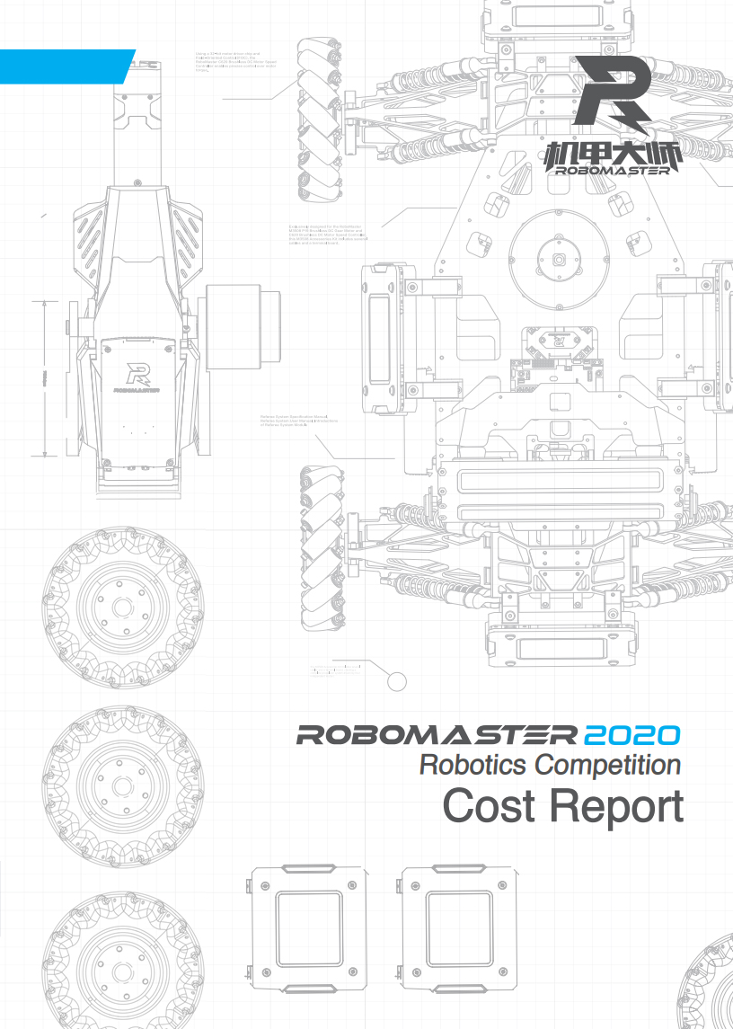
Table of Contents
Foreword 3
1. Cost Overview 4
2. Cost Analysis 5
2.1 Expenses Report 5
2.1.1 Report by Items 5
2.1.2 Report by Categories 6
2.2 Manpower Report 7
3. Conclusion and Planning 9
3.1 Conclusion of Experience 9
3.2 Capability Building 9

Foreword
A cost report is where a team aggregates and analyzes its costs for the current competition season, and is prepared by the team after completing its main research and development tasks for the season. It represents the progressive conclusion of a team’s long-term cost optimization efforts, and is beneficial to the team’s sustainable development.
This report mainly provides an overview and conclusion of a team’s budget, and also includes labor costs involved under other cost factors. The main body of the report comprises three chapters: cost overview, cost analysis, and conclusion and planning.
Cost overview details the current situation of the competition season. Cost analysis includes budget reports, working hours reports, and corresponding analysis of irregularities. This report is aimed at concluding and planning based on failed or successful experience and cases, as well as presenting the current cost control capability and plans
Note: Avoid simply copying and pasting meaningless content from other resources. You are simply expected to provide a clear description of your team’s current progress and issues. You are not required to produce a lengthy report.

Cost Overview
Review the team’s spending for the entire competition season at the closing phase, and describe any further expenses that will be incurred within the plan for the season. Proof needs to be provided in the form of a small amount of macro data.
For example: The team has completed the core development tasks from all its plans within the original budget in the current competition season. A small budget overrun is estimated, which is within the controllable range. The initial budget was 150k. We have spent 100k after launching the second generation of all robot types. We estimate that 20k will be used as research and development expenses for the upgrade of some robots after the Regional Competition, and 40k for other expenses. The estimated amount of budget overrun for the entire season is 10k. This can be covered by prize money or other scientific innovation funding.

Cost Analysis
Cost analysis includes two aspects: expenses and manpower

Expenses Report
The expenses report should provide analyses by items and categories, with their total costs being the same

Report by Items
Item | Budget  (RMB 0,000) | Disbursed (RMB 0,000) | Subsequent Expenses Required (RMB 0,000) | Normal or Not | Remarks
To add or remove based on actual items | Initial budget for the item at start of season | Disbursements made so far | Subsequent expenses still required based on the current situation, rather than subtracting disbursements from budget | Neither budget overruns nor a large amount of balance is normal | The reason(s) for the irregularity and general description of subsequent expenses still required
Total Cost | 15 | 12 |  | Yes
Standard | 3 |  |  | Yes
Hero | 1 |  |  | Yes
Engineer | 1.5 |  |  | Yes
Sentry |  |  |  | Yes
Dart System |  |  |  | Yes
Radar |  |  |  | Yes
Team Operation | 4 |  |  | No
Battlefield Components | 0.5 |  |  | Yes
Team Assets | 2.5 |  |  | Yes
Other items included as required |  |  |  | Yes

Report by Categories
Category | Budget (RMB 0,000) | Disbursed (RMB 0,000) | Subsequent Expenses Required (RMB 0,000) | Normal or Not | Remarks
To add or remove based on actual categories | Initial budget for the item at start of season | Disbursements made so far | Subsequent expenses still required based on the current situation， rather than subtracting disbursements from budget | Neither budget overruns nor a large amount of balance is normal | The reason(s) for the irregularity and general description of subsequent expenses still required
Total Cost | 15 | 12 |  | Yes
Official Products | 3 |  |  | Yes
Mechanical Processing | 1 |  |  | Yes
Non-official Products | 1.5 |  |  | Yes
Accommodation | 1.4 |  |  | Yes
Travel | 1 |  |  | Yes
Tools | 0.5 |  |  | Yes
Equipment | 4 |  |  | No
Consumables | 0.5 |  |  | Yes
PCBA | 2.5 |  |  | Yes
Other items included as required |  |  |  | Yes
Items and categories with irregular cost status needs to be analyzed, with the reason(s) identified and an improvement plan laid out.

Manpower Report
The manpower report is prepared based on the items, where the team’s effective working hours coefficient is first calculated, followed by the preparation of the report.
Effective working hours coefficient = (Average weekly working hours for each regular member of the team)/(7 days*8 hours) = ______
Item | Budgeted Manpower (persons*month) | Manpower Used (persons*month) | Subsequent Manpower Required (persons*month) | Normal or Not | Remarks
To add or remove based on actual items | Manpower planned for the item at start of season | Disbursements made so far | Subsequent expenses still required based on the current situation, rather than subtracting disbursements from budget | Neither budget overruns nor a large amount of balance is normal | The reason(s) for the manpower irregularity and general description of subsequent expenses still required
Total Manpower | 160 | 100 | 70 | No
Standard | 32 | 24 | 0 | No
Hero | 16 | 16 | 4 | Yes
Engineer | 24 |  |  | Yes
Sentry |  |  |  | Yes
Dart System |  |  |  | Yes
Radar |  |  |  | Yes
Team Management |  |  |  | No
Battlefield Components | 0 |  |  | Yes
Other items included as required |  |  |  | Yes
Any item with irregularity in manpower cost needs to be analyzed, with the reason(s) identified and an improvement plan laid out.

Conclusion and Planning
A conclusion is provided based on the cost analysis data from the previous chapter. The main purpose of this chapter is to conclude and review the team’s costs from the perspective of the whole team, and to provide useful advice for the future.

Conclusion of Experience
Failed or successful cases should be shared in this section from the cost control and management efforts of the team, and should be substantiated using methodology in reference to the case study.

Capability Building
A description of the team’s current cost control capability and plans should be provided, and any concept for a final blueprint, if available, can also be included.
For example: We have adopted highly productive office approval software and financial management software to increase our research and development efficiency, and bring greater transparency to the control of our funds. We have performed item quality control using a well-established assessment system, and have enhanced the technology accumulation of virtual prototypes to reduce the number of prototype iterations.

