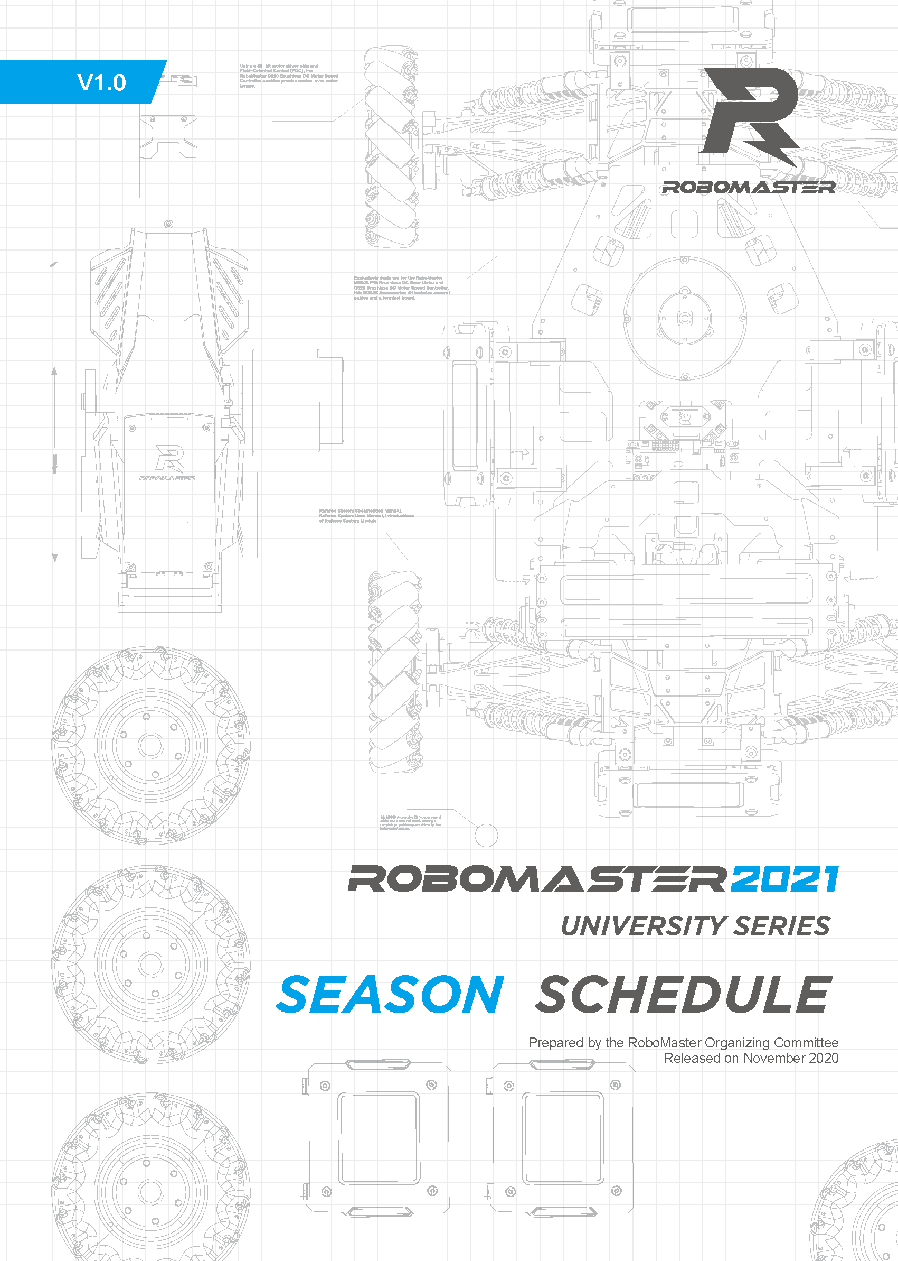

RoboMaster Referee System User Manual

Release: RoboMaster Organizing Committee
Version: 错误!未知的文档属性名称
Date: 2019/1/1
Table of Contents
1. Team Culture 4
1.1 Understanding of the culture and significance of the RoboMaster Competition 4
1.2 Core Values of the team 4
1.3 Common Goals of the Teams 4
2. Project Analysis 5
2.1 Rules Interpretation 5
2.1.1 Standard Robot 5
2.1.2 Sentry Robot 5
3. Team Structure 6
4. Infrastructure 7
4.1 Available Resources 7
4.2 Team Management Tools 7
4.3 R&D Management Tools 7
4.4 Resource Management 7
4.5 Financial Management 7
5. Business and Promotional Plan 8
5.1 Promotion Campaign Plan 8
5.2 Business Plan 8
6. Team Rules and Regulations 9
6.1 Introduction to the Team 9
6.2 Mechanisms for Team Management 9
6.2.1 Review and Decision-Making Mechanism 9
6.2.2 xx Mechanism 9

Team Culture

Understanding of the Culture and Significance of the RoboMaster Competition
Write here

Core Values of the Team
Write here

Common Goals of the Teams
Write here

Project Analysis

Rules Interpretation
Write here

Standard Robot
Write here (requirements analysis and ideas of design)

Sentry Robot
Write here (requirements analysis and ideas of design)

Team Structure
Roles | Category | Role |  | Division of Responsibilities | Recruitment of Team Members
Supervisor
Advisor
Regular Members | Management | Captain
 |  | Vice Captain
 |  | Project Manager
 | Technical Executive | Mechanical | Team Lead
 |  | Mechanical | Team Member
 |  | Electrical | Team Lead
 |  | Electrical | Team Member
 |  | Algorithm | Team Lead
 |  | Algorithm | Team Member
 | Operation | Publicity
 |  | Sponsorship
 |  | Finance
Reserve Member |  | Mechanical
 |  | Electrical
 |  | Algorithm
 |  | Operation

Infrastructure

Available Resources
Time | Source | Amount | Unit | Initial Use Plan
Expenses Report | School/Department
Expenses Report | Sponsored
Materials | Sponsor
Materials | Legacy
Processing Resources

Team Management Tools
Write here

R&D Management Tools
Write here

Resource Management
Robot Type | Technical Aspect | Type | Link
xx Robot/  Common to all types of robots | Mechanical | Open-source materials | Link
Write here

Financial Management
Write here

Business and Promotional Plan

Promotion Campaign Plan
Write here

Business Plan
Write here

Team Rules and Regulations

Introduction to the Team
Write here

Mechanisms for Team Management

Review and Decision-Making Mechanism
Write here

xx Mechanism
Write here

