RoboMaster 2020 High School Winter Camp Resume
Name |  | Gender |  |  | (Photo)
English grade |  | Grade | Latest mock exam grade
School |  | Research track | Mechanical / Embedded System / Algorithm …
Current grade level |  | Contact information
Province |  | Email
Project experience
(the projects you participated in, such as robotics competitions, patents, self-guided designs, etc.; please elaborate on the technical details of the projects or competitions and your roles in them)
Robotics-related activities you participated in | Your role | Main task(s) |  | Awards
Select one below | Select one below
Description: FRC/RTC/CRC; VEX;  DIY; RoboMaster Summer/Winter camp | Captain; module manager; | Example: XX Competition in XX (year) (activity), developing XX Module using XX technology to perform XXX functions |  | Example: Received the national/regional/city level First/second/third prize etc.
Programming language, software, and industrial skills
(The following topics aim to help you better understand the basics of the winter camp and gain relevant knowledge in advance. This will help you to learn and work more efficiently during the winter camp, find your track of interest, and choose the appropriate topic to research. These questions include self-learning components. Please study the learning materials provided by the organizers. You are expected to present your process of thought and not simply provide the final answer. Please answer questions of at least one track.)

I. Open question:
What impact do you think 5G technology will have on education in the future? Please elaborate on your own point of view in a specific form.

II. Compulsory questions for the Mechanical track:
1. The figure below shows a Mavic 2 drone. Indicate with screenshots its power source and sensor:
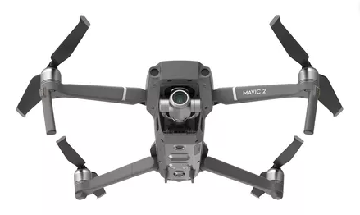
2. Draw the following models using 3D modeling software:
① Draw the 3 parts below and provide the final screenshot:
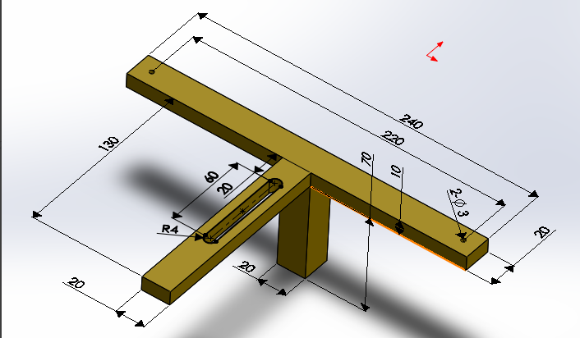
(Part 1)
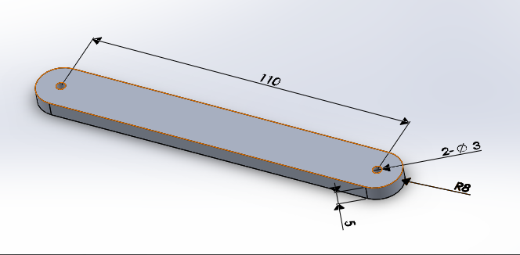
(Part 2)
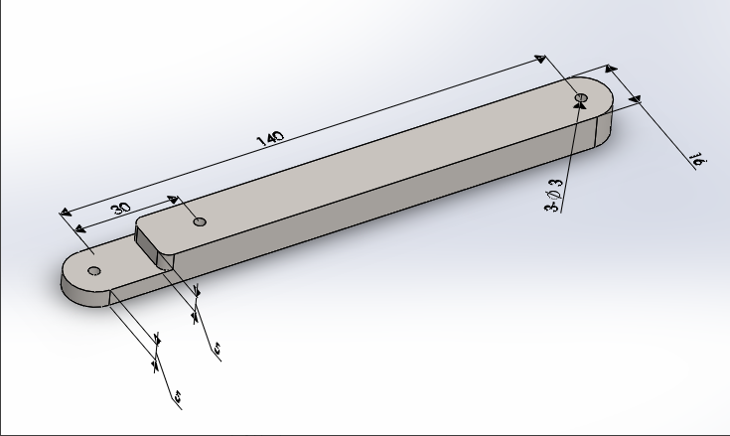
(Part 3)
② Draw the following assembly model using the above 3 parts. The model must be able to clamp a cube with a side length of 200mm (designing of some small supporting parts is permitted). Provide a six-view diagram of the final assembly.
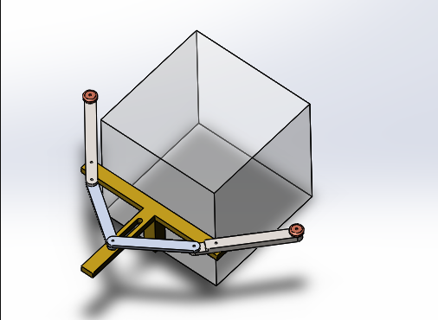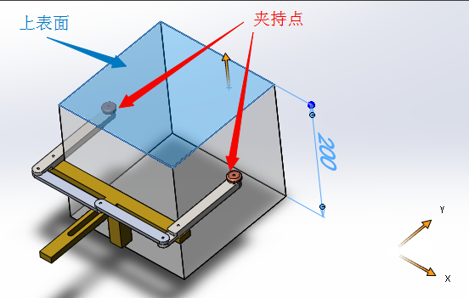
③ Assuming the weight of the cube is 10kg, the clamping point is at the end of Part 3, the coefficient of friction between the clamping point and the cube is 0.5, and the direction of gravity is perpendicular to the upper surface. Calculate the pressure received by Part 2. (assuming all parts are rigid bodies)
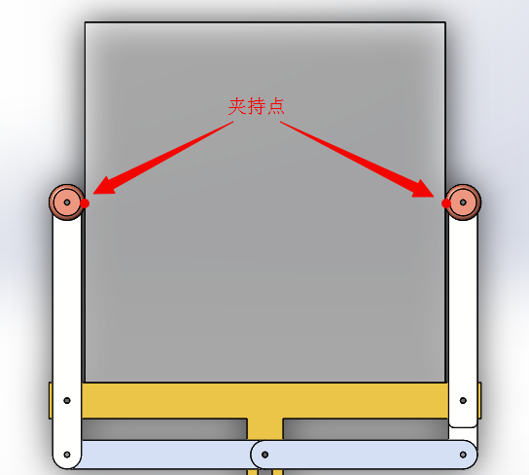

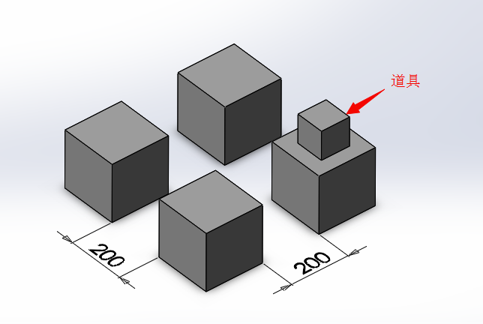
3. A tool is secured on the top of a cube with a side length of 200mm. You are required to operate a robot to lift the tool to a height of 800mm through the method of stacking using 3 other cubes with also side lengths of 200mm. The initial positions of the 4 cubes are shown in the figure. The number of motors or cylinders, and velocity, power and size are not restricted under the competition rules. However the fewer motors used, the higher the score. The quality of the cubes is not taken into consideration, and it is assumed the cubes cannot be damaged through clamping (PS:the use of suction cups, adhesive tapes or hook-and-loop fasteners as clamping mechanisms is prohibited). Answer the following questions:
① Please describe in words several structural solutions for a robot capable of performing such a function, and analyze their strengths and weaknesses
② Choose a solution that is the best in your opinion and produce a 3D drawing
③ Choose 3 components of different materials from the above mechanism designed by you and describe their respective material characteristics and processing technology.
④ You are leading a 2-member team (3 persons in total) to complete this project, of which the process from designing to final production must be completed within 7 days. Provide a rough plan of how this will be achieved.
4. Produce a simulation of the static stress and force on Part 1 using SolidWorks - provide a screenshot of the simulation describing the final state of forces when the external load is 10N (as in the figure below)
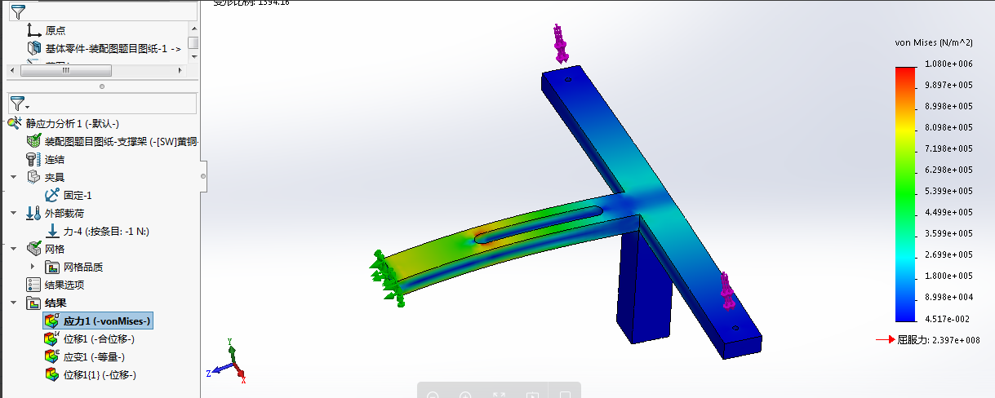
Ⅲ. Compulsory questions for Embedded Systems and Algorithm tracks:
1. Write a function with a string of letters in ascending order as its input, with the output being the letter missing in the string.
For example: “abcdf” -> 'e'、”OQRS” -> 'P'.
Only C or Python can be used.
2. All values in computers are converted in binary form to be stored and computed. For example an integer without symbols 1234 is 10011010010 after conversion into binary form. Write a function that computes how many 1 digit(s) there are in a string without symbols after being converted into a binary number.
For example: 1234->10011010010 = 5
Only C or Python can be used
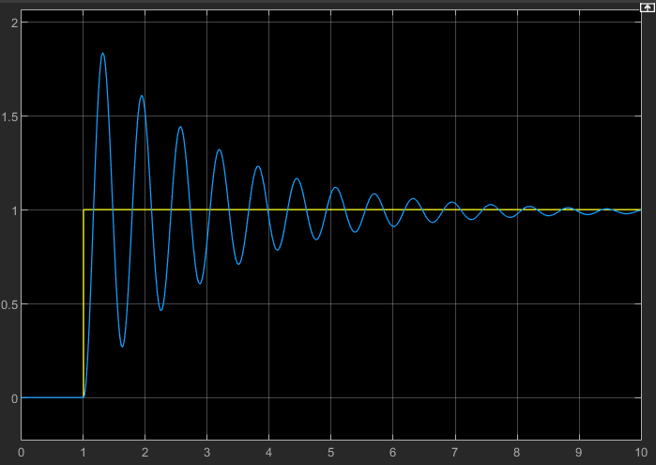
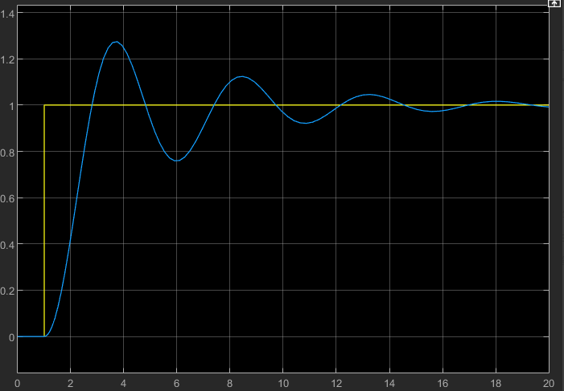
3. The three figures below show the graphs of the changing set values and output values of three PID controller systems with different parameters. Analyze and find out what issues exist in these three PID controllers. How should the parameters be adjusted?
(1) (2)
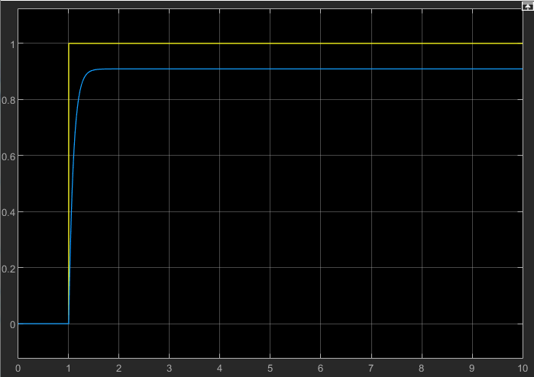

(3)
4. Rainforests in Brazil suffered a major fire in early August this year that has been ongoing for weeks. You are required to build a drone to assist the Brazilian government in putting out the fire. The drone must possess the following functions (not taking into account the quality, size and endurance of the drone):
a.Able to survey fire situations, identify ignition points and generate fire heat maps in an intelligent manner.
b.Where necessary, able to automatically map out routes to navigate trapped personnel out of the rainforests.
It is known that humidity is high in rainforests and GPS signals are generally weak when flying in rainforest areas. Based on this scenario, answer the following questions:
Reference info: Mavic Enterprise version, Agras T16 Plant Protection drone, VTOL Fixed-wing mode
① Describe briefly the main working principles and algorithmic process for a proposed drone attitude algorithm. Suggested word limit: 180 characters.
② Design a sensor solution that meets the requirements for the tasks in the above scenario - provide a diagram of the sensors with the communication buses connecting each sensor mapped out. (Suggested word limit: 260 characters; diagram not included in word count)
③ If you are leading a 3-member team (a total of 4 persons) to complete this project, set out your project plan and a breakdown of software functions, describing the roles of your team members in the project and the technical aspects they will be in charge of. (Suggested word limit: 350 characters)
5. Coordinate transformation is a description of the positions of a spatial entity, and a process of transformation from one coordinate system to another. It is achieved by establishing one-to-one correspondences between two coordinate systems. Learn about coordinate transformations in a three-dimensional space, and answer the following questions:
① Describe how many degrees of freedom are required to describe an object’s position and attitude in a three-dimensional space?
② What mathematical structure is used to express or describe coordinate transformations in a three-dimensional space?
③ Write the following program in an ROS:
Coordinate Systems A and B are given. The transformation of position (x, y, z) from Coordinate System A to B is (1, -2, 0), and the transformation of angle (roll, pitch, yaw) is (-90°, 0, 45°). Coordinate System A has a position and attitude point M, of which the position coordinate (x ,y, z) is (1, 1, 1) and angle (roll, pitch, yaw) is (0, 0, 0)
a) Publish the static coordinate transformation between Coordinate Systems A and B
b) Publish the position and attitude topic information of the position and attitude point M (in Coordinate System A) using geometry_msgs::PoseStamped
c) Publish the position and attitude topic information of the position and attitude point N (in Coordinate System B) using geometry_msgs::PoseStamped, so that point N and M overlap in the space
d) Display the TF transformation between Coordinate Systems A and B, and the position and attitude information of point M and N in the ROS visualization interface rviz, and include the screenshot in your answer

